**FPT ACADEMY INTERNATIONAL**

**FPT – APTECH COMPUTER EDUCATION**

**Centre Name: ACE-HCMC-2-FPT.**

**Address: 590 Cach Mang Thang 8, District 3, Ho Chi Minh City, Viet Nam.**

**Online Shopping Cart**

|  |  |  |
| --- | --- | --- |
| **Supervisor** | **MR. DINH HOAI VU** | |
| **Batch** | **T1.2302.E1** | |
| **Group. No** | **3** | |
| **Seri. No** | **Student Name** | **Enrollment Number** |
| **1** | **NGÔ ĐÌNH TÂN** | Student1455765 |
| **2** | **NGUYỄN THỊ NGỌC MAI** | Student1457506 |
| **3** | **NGUYỄN THÀNH NHÂN** | Student1455763 |
| **4** | **PHAN VĂN GIỮ** | Student1455761 |

Month 6 Year 2024

**Table of Contents**

**A.** **REVIEW 1** 3

**I.** **ACKNOWLEDGE** 3

**II.** **INTRODUCTION** 4

**III.** **PROBLEM DEFINITION** 5

**1.** **FROM THE VIEW POINT OF CUSTOMER** 5

**2.** **FROM THE VIEW POINT OF THE ADMINISTRATOR** 5

**3.** **FROM THE VIEW POINT OF THE EMPLOYEE** 5

**IV.** **CUSTOMER'S REQUIREMENTS SPECIFICATIONS (CRS) CLIENT:** 6

**1.** **INPUT TO THE SYSTEM:** 6

**2.** **OUTPUT FROM THE SYSTEM:** 7

**V.** **SCOPE OF WORK** 8

**a.** **Login**: 8

**b.** **Ordering products:** 9

**c.** **Database:** 9

**VI.** **HARDWARE/ SOFTWARE REQUIREMENTS:** 9

**a.** **HARDWARE** 9

**1.** **SOFTWARE** 10

**b.** **DEVELOPMENT SOFTWARE** 11

**c.** **TECHNOLOGY** 11

**VII.** **TASK SHEET REVIEW 1** 12

**B.** **REVIEW 2** 13

**I.** **USECASE** 13

**II.** **E-R DIAGRAM** 15

**III.** **DATABASE** 16

**1**. **Users Table** 16

**2. Types Table** 17

**3. Products Table** 17

**4**. **StoreImages(for exchange/ refund images only) Table** 18

**5**. **Variants Table** 19

**6**. **VariantAttributes Table** 20

**7**. **Categories Table** 20

**8**. **ProductImages Table** 21

**9**. **Carts Table** 21

**10**. **Orders Table** 22

**11**. **Reviews Table** 23

**12**. **ReviewImages Table** 23

**13. Payment Table** 24

**14**. **Addresses Table** 25

**15**. **Exchanges Table** 26

**16**. **Refunds Table** 27

**IV.** **DFD** 28

**1.** **LEVEL 0** 28

**2.** **LEVEL 1** 28

**3.** **LEVEL 2** 32

**V.** **GUI STANDARDS DOCUMENT** 40

**VI.** **TASKSHEET REVIEW 2** 42

**C. REVIEW 3** 43

**I.** **UI Design** 43

**1.** **Home page** 43

**2.** **Product detail** 46

**3.** **Rating and comment** 47

**4.** **Account information** 48

**5.** **Address book page** 49

**6.** **Register page** 49

**7.** **Login page** 50

**8.** **Manage products page** 50

**9.** **Create Product** 51

**10.** **Manage employee page** 53

**11.** **Create employee page** 54

**12.** **Dashboard page** 54

**13. Order and payment page** 55

**14. Login form admin** 57

**16. Create employee** 58

**II.** **SITE MAP** 59

**III.** **UNIT TESTING CHECK LIST** 60

**IV.** **TASKSHEET REVIEW 3** 61

# **REVIEW 1**

## **ACKNOWLEDGE**

We dedicate this chapter to expressing our sincere and heartfelt gratitude to all those who provided invaluable support throughout the implementation of this project.

First and foremost, we would like to extend our heartfelt thanks to our dedicated instructor, Mr. Hoai Vu. His meticulous guidance, invaluable suggestions, and constant encouragement helped us overcome not only technological challenges but also psychological pressures. Without his companionship, we would not have successfully completed this work.

Secondly, we highly appreciate the Project Team at the Head Office. They provided us with an excellent opportunity to apply the knowledge we had learned in practice. We are confident that the valuable experiences gained from this project will greatly support our future careers.

Thirdly, we would also like to express our deep gratitude to all the staff members at our center. Their support, encouragement, and unwavering assistance not only helped us complete our work effectively but also allowed us to learn and grow throughout the process.

Lastly, but certainly not least, we wish to express our heartfelt thanks to all our classmates and team members. Your enthusiastic support, open assistance, and strong team spirit have provided us with the motivation and energy to overcome all challenges and successfully accomplish our tasks.

We hope that these words of gratitude can somewhat express our profound appreciation to everyone. We believe that, with everyone's support and encouragement, we will achieve even greater heights in the future.

## **INTRODUCTION**

Arts is a stationery shop that specializes in selling art supplies, gift articles, greeting cards, dolls, files, handbags, wallets, and some beauty products. Due to the high demand for items such as greeting cards, gift articles, and handbags, as well as the busy nature of modern life where people hardly have time for in-store shopping, this project aims to develop an e-commerce website to meet the online shopping needs of customers.

**For Arts’s customer base:**

* Convenience in shopping: Customers can shop anytime, anywhere through Arts' website without the need to visit a physical store, saving time and effort.

• Diversity in choices: The website offers a wide range of products from art supplies to gifts, from greeting cards to handbags and beauty products, ensuring abundant options for every customer's needs.

• Secure payment options: Customers can make online payments through various secure methods such as credit cards, or cash on delivery.

• Detailed product information: Customers can access detailed information about each product, including descriptions, photos, and prices, helping them make informed purchasing decisions.

• Feedback from other customers: The website allows customers to rate and provide feedback on products, giving buyers an overall and reliable view of product quality.

• Customer service: Arts provides professional customer support services through the website, helping to address any queries and requests from customers.

• Quick search capability: Arts' website features a smart search function, allowing customers to easily find the products they are looking for in just a few simple steps.

• Easy account management: Customers can easily manage their personal information and purchase history through the website, including updating delivery addresses, reviewing past orders, and tracking the status of current orders.

• Seamless online shopping experience: The website is designed to provide a smooth and easy online shopping experience, from placing orders to payment, ensuring customers have an enjoyable and convenient shopping experience.

• Easy returns and order cancellation: Customers have the option to return items and cancel orders before they are shipped, providing added flexibility and peace of mind in their purchasing decisions. This feature ensures that customers can shop with confidence, knowing that they have the ability to make changes or returns if needed, enhancing their overall shopping experience with Arts.

## **PROBLEM DEFINITION**

After analyzing the project specifications of Arts, to fulfil customer’s requirements properly, we came to conclusion that in order to achieve the best result, we should deal with following queries:

### **FROM THE VIEW POINT OF CUSTOMER**

#### Current Problems:

* Customers must visit the physical store to purchase products, which is time-consuming and inconvenient.
* There is no online platform to browse products, check prices, or place orders from home or office.
* Customers have no way to check product availability before visiting the store.
* Lack of detailed product information online (e.g., price, description).
* No option to track orders or check order status online.
* Limited payment methods are inconvenient for customers.
* No automated system for order confirmation or unique order identification.
* Returns or replacements are not managed efficiently.
* No online feedback or complaint system.

#### Desired Solutions:

* An online platform where customers can browse products, check availability, and view detailed descriptions and prices.
* Ability to place orders online using various payment methods (credit card, VPP, cheque, DD).
* Automated system for order tracking and status updates.
* Easy returns and replacements through the online system.
* Option for customers to provide feedback and reviews on products and services.

### **FROM THE VIEW POINT OF THE ADMINISTRATOR**

#### Current Problems:

* No automated system to manage product inventory, making it difficult to track stock levels.
* Lack of a central database to maintain and update product details, employee information, and customer orders.
* Manual handling of orders and deliveries, which is inefficient and prone to errors.
* No system to generate unique product IDs and order numbers automatically.
* Difficulty in managing employee access and maintaining security of sensitive information.
* No centralized system to view and respond to customer feedback.

#### Desired Solutions:

* A comprehensive database to manage product inventory, employee details, customer orders, and delivery information.
* Automated generation of unique product IDs and order numbers.
* An admin panel to update product details, manage employees, view orders, and handle deliveries.
* Secure login system for admin, employees, and customers with role-based access.
* Efficient system for handling customer feedback and resolving issues promptly.

### **FROM THE VIEW POINT OF THE EMPLOYEE**

#### Current Problems:

* Manual process of checking and updating order details, leading to inefficiency and errors.
* No centralized system to view the status of orders and manage deliveries.
* Limited ability to change personal information, such as passwords.
* Lack of clear communication channels to receive and act on customer feedback.
* No system to efficiently manage returns and replacements.

#### Desired Solutions:

* An employee portal to view and update order details, manage deliveries, and track stock levels.
* Ability to change personal information securely.
* Clear communication channels for receiving customer feedback and acting on it.
* Efficient management of returns and replacements through the system.
* Tools to streamline the dispatch process and ensure timely delivery of orders.

## **CUSTOMER'S REQUIREMENTS SPECIFICATIONS (CRS) CLIENT:**

**ARTS BUSINESS/PROJECT OBJECTIVE:**

Arts aims to provide a user-friendly platform for both office supply providers and customers, facilitating smooth management, ordering, and browsing of office supplies.

### **INPUT TO THE SYSTEM:**

#### From the Customer:

##### **Product Browsing:**

* Search queries for products (keywords, categories).
* Filters (price range, brand, availability).

##### **Account Management:**

* Registration details (name, email, password, contact information).
* Login credentials (username, password).

##### **Order Placement:**

* Selected product IDs and quantities.
* Shipping details (address, contact number).
* Payment information (credit card details, cheque details).
* Delivery preferences (standard, express).

##### **Order Management:**

* Order cancellation requests.
* Return/replacement requests with reasons.

##### **Feedback and Reviews:**

* Product feedback and ratings.

#### From the Administrator:

##### **Product Management:**

* Product details (price, description, availability).
* Unique product IDs.

**Employee Management**:

* Employee information (username/login ID, password).
* Employee access rights.

**Order Management:**

* View and manage all orders.
* Update order status (dispatched, delivered).

#### From the Employee:

##### **Order Processing:**

* Access to order details.
* Update order status (processed, dispatched).

##### **Account Management:**

* Change personal password.

### **OUTPUT FROM THE SYSTEM:**

#### For the Customer:

##### **Product Information:**

* Detailed product descriptions (price, features, availability).
* Search results and filtered lists.

##### **Account Information:**

* Registration confirmation.
* Account details and order history.

##### **Order Confirmation and Tracking:**

* Unique 16-digit order number.
* Payment and order status updates.
* Estimated delivery and tracking info.

##### **Notifications:**

* Order confirmation, dispatch, and delivery notifications.

##### **Feedback and Reviews:**

* Acknowledgment of feedback.
* Display customer reviews on product pages.

#### For the Administrator:

##### **Dashboard:**

* Overview of orders, stock.
* Detailed product, order.

##### **Notifications:**

* Alerts for orders

##### **Employee Management:**

* List of employees with roles and statuses.

#### For the Employee:

##### **Order Processing:**

* List of orders to process with detailed info.
* Status updates for each order.

##### **Notifications:**

* Alerts for new orders and feedback.

## **SCOPE OF WORK**

The application should perform the following functions:

### **Login**:

• In the application, there are 3 roles: "admin", "employee", and "customer". The administrator will log in under the name "admin". The admin can create employees. Users can create their own accounts to become "customers".

• For the "admin" role: manage inventory, manage employees, manage products.

• For the "employee" role: can view and manage orders, revenue reports.

• For the "customer" role: can view and manage orders that they have placed.

### **Ordering products:**

• When a customer places an order for a product and the ordered product will be added to the order management.

• For the order which is placed through the credit card payment or through cheque, the payment should be cleared first and then only the product will be dispatched to the customer’s premises

### **Database:**

• Information about products, categories, orders and users will be stored in the database.

## **HARDWARE/ SOFTWARE REQUIREMENTS:**

### **HARDWARE**

#### a.1 Web Server

|  |  |
| --- | --- |
| **Processor** | Intel Core I7 or higher. |
| **Memory** | 16 GB RAM or greater. |
| **Modem/ADSL** | Internet access is required. |

#### a.2 Client

|  |  |
| --- | --- |
| **Processor** | Intel Core I3 or higher. |
| **Memory** | 4 GB RAM or greater. |
| **Monitor** | Super VGA (1024x768) or higher resolution. |
| **Modem/ADSL** | Internet access is required. |

### **SOFTWARE**

#### Web Server

|  |  |
| --- | --- |
| **Operation System** | Window 7 or later. |
| **Browser** | Google Chrome version 3.5. |
| **Database** | SQL Server |
| **Software** | Internet Information Service |
| ASP.NET Core API |

#### Client

|  |  |
| --- | --- |
| **Operation System** | Window 7 or higher. |
| **Browser** | Google Chrome version 3.5. |

### **DEVELOPMENT SOFTWARE**

* + - Microsoft Windows 11.
    - SQL Server.
    - Visual Studio Code.
    - Visual Studio 2022
    - Google Chrome.

### **TECHNOLOGY**

* + - ASP.NET core API
    - React.
    - React-Query
    - Styled Components

## **TASK SHEET REVIEW 1**

|  |  |  |  |  |  |  |  |  |
| --- | --- | --- | --- | --- | --- | --- | --- | --- |
| **Project: Liquor Stores** | | **Project Name** | **Activity Plan Prepared By** | **Date of Preparation of Activity Plan:** | | | | |
| **Sr./ No.** | **Task** | **Actual Start Date** | | **Actual Days** | **Team member name** | **Status** |
| **1** | **Acknowledgment** | **Online Shopping**  **Cart** | Tân | 08/06/2024 | | 1 | Giữ | Completed |
| **2** | **Introduction** | 08/06/2024 | | 1 | Giữ | Completed |
| **3** | **Problem Definition** | 08/06/2024 | | 1 | Giữ | Completed |
| **4** | **Customer Requirement Specification (CRS)** | 08/06/2024 | | 1 | Giữ | Completed |
| **5** | **Scope of Work** | 08/06/2024 | | 1 | Tân | Completed |
| **6** | **Hardware/Software Requirement** | 08/06/2024 | | 1 | Tân | Completed |
| **7** | **Task Sheet** | 08/06/2024 | | 1 | Giữ | Completed |
| Date: 08 June 2024 | | | | | | | | |
| **Signature of Instructor:**  **MR. DINH HOAI VU** | | | | | **Signature of Team Leader:**  **MR. NGO DINH TAN** | | | |

# **REVIEW 2**

## **USECASE**

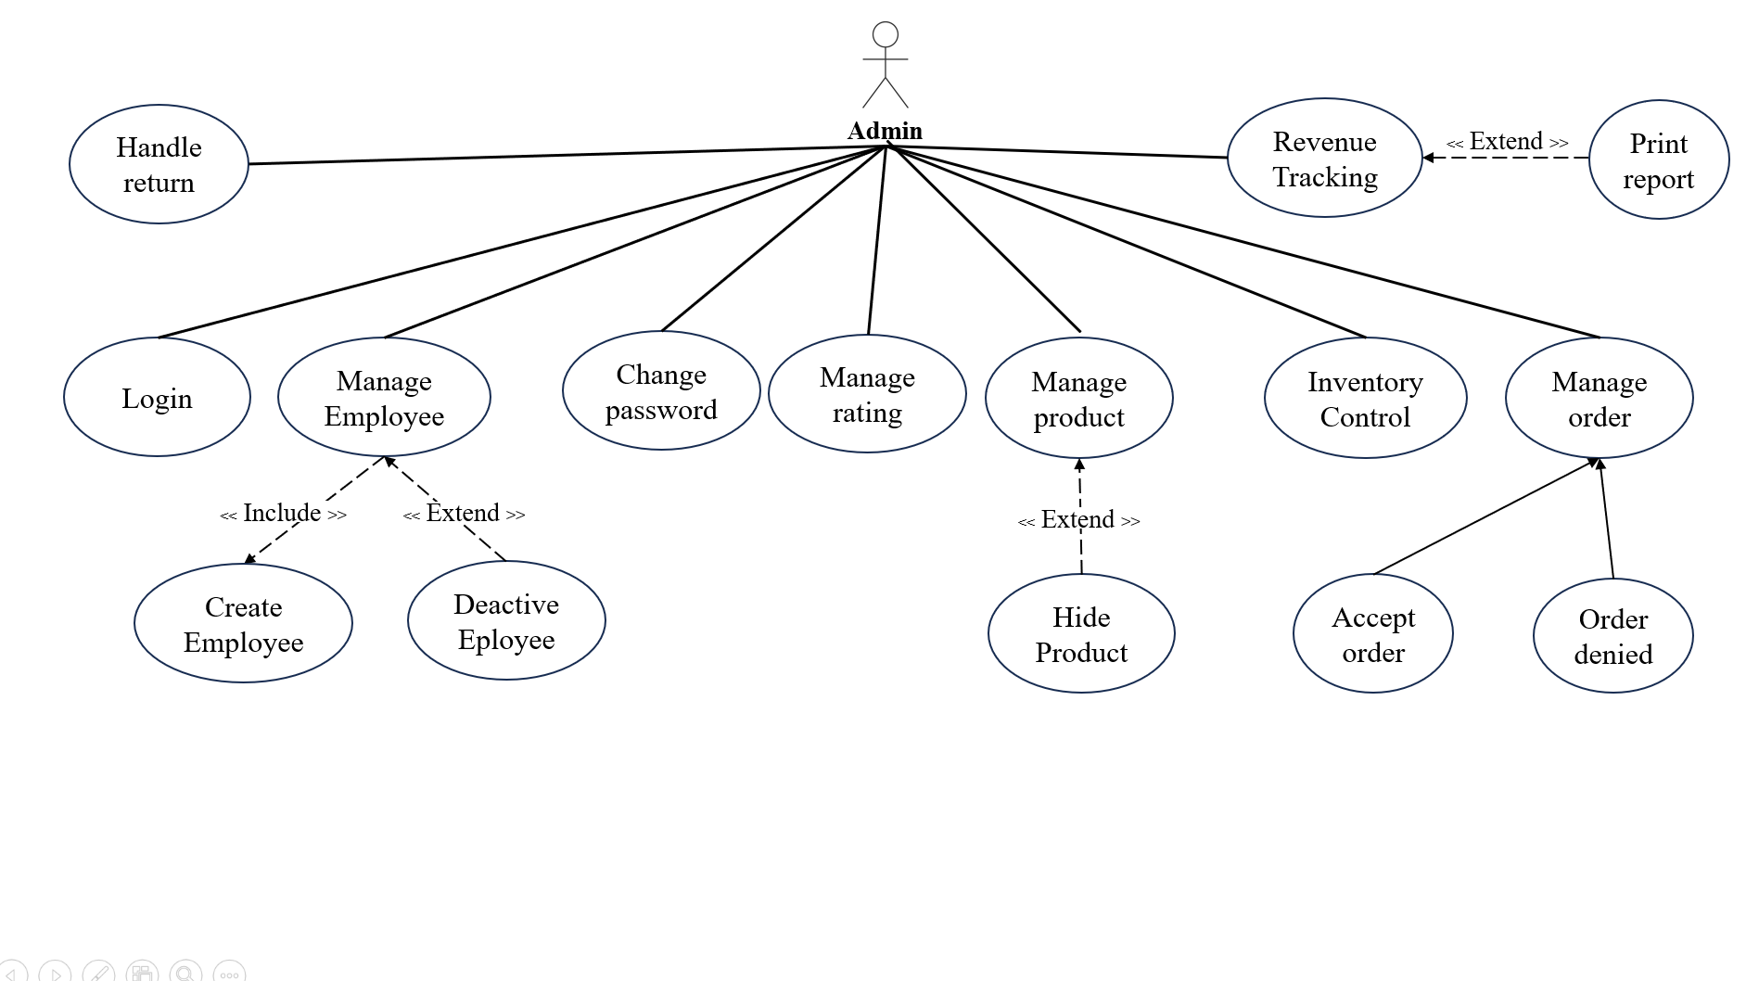

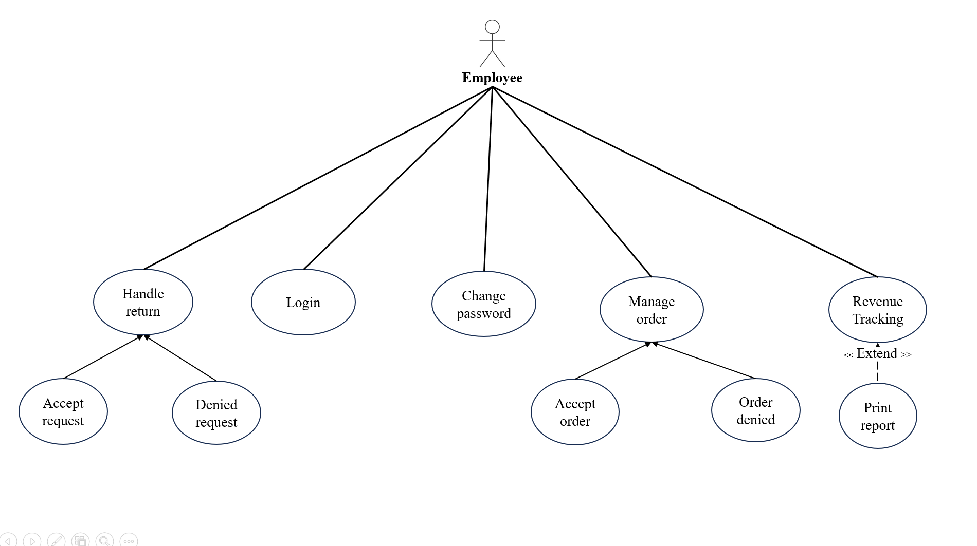

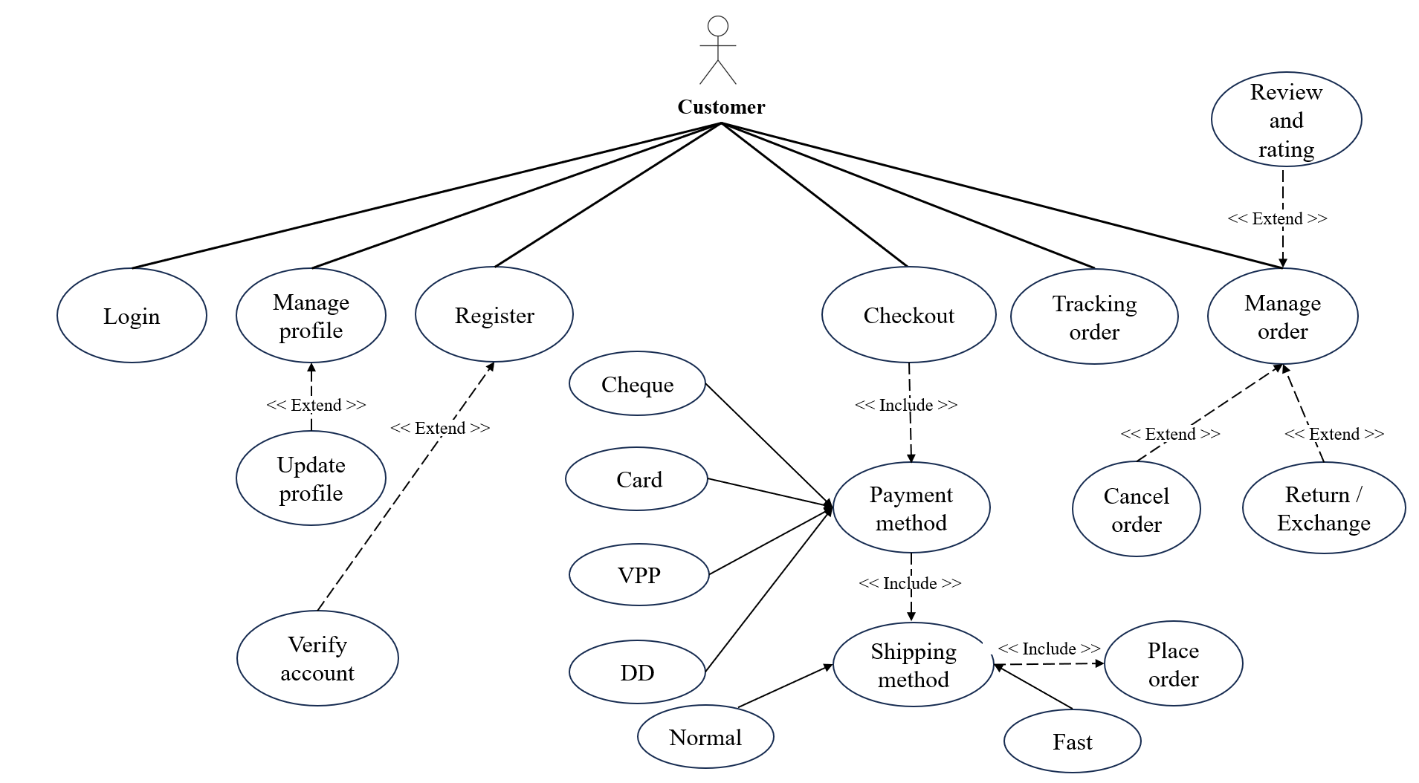

## **E-R DIAGRAM**

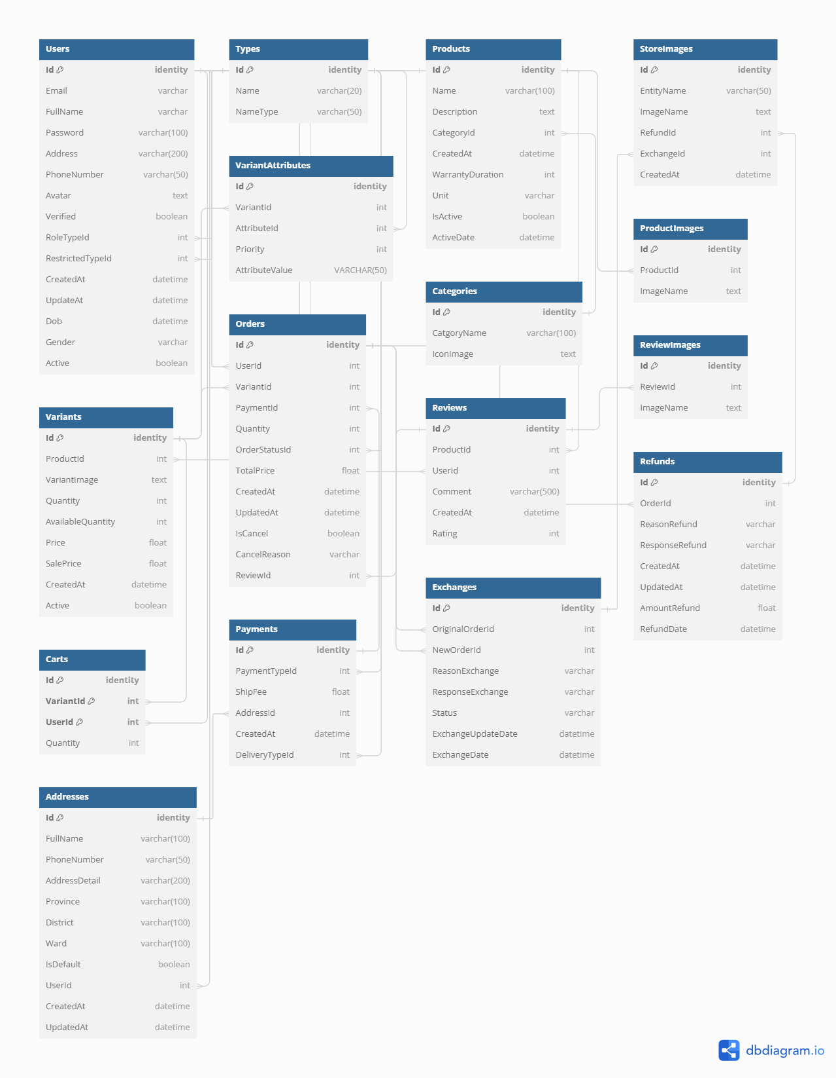

## **DATABASE**

### **1**. **Users Table**

|  |  |  |  |
| --- | --- | --- | --- |
| **Field Name** | **Type Data** | **Description** | **Notes** |
| Id | Identity PK | Primary Key | Unique identifier for each user. |
| Email | Varchar | User's email address |  |
| FullName | Varchar | User's full name |  |
| Password | Varchar(100) | User's password |  |
| PhoneNumber | Varchar(50) | User's phone number |  |
| Avatar | Text | User's avatar image |  |
| Verified | Boolean | Whether the user is verified |  |
| RoleTypeId | Int | [ref: > Types.Id] | Reference to the table.Types |
| CreatedAt | DateTime | User creation timestamp |  |
| UpdateAt | DateTime | User last updated timestamp |  |
| Dob | DateTime | User's date of birth |  |
| Gender | Varchar | User's gender |  |
| Active | Boolean | Whether the user account is active |  |

### **2. Types Table**

|  |  |  |  |
| --- | --- | --- | --- |
| **Field Name** | **Type Data** | **Description** | **Notes** |
| Id | Identity PK | Primary Key | Unique identifier for each type. |
| Name | Varchar | Type name | Name of value for example : Admin, Eployee for NameType is UserRole, color, size, material for NameType VariantAttribute,… |
| NameType | Varchar(50) | Type description | Summary of 5 different types: UserRole, VariantAttribute, PaymentType, DeliveryType, OrderStatus. |

### **3. Products Table**

|  |  |  |  |
| --- | --- | --- | --- |
| **Field Name** | **Type Data** | **Description** | **Notes** |
| Id | Identity PK | Primary Key | Unique identifier for each product. |
| Name | Varchar(100) | Product name |  |
| Description | Text | Product description |  |
| CategoryId | Int | [ref: > Categories.Id] | Reference to the table.Categories |
| CreatedAt | DateTime | Product creation timestamp |  |
| WarrantyDuration | Int | Warranty duration in months |  |
| Unit | Varchar | Unit of measurement |  |
| IsActive | Boolean | Whether the product is active |  |

### **4**. **StoreImages(for exchange/ refund images only) Table**

|  |  |  |  |
| --- | --- | --- | --- |
| **Field Name** | **Type Data** | **Description** | **Notes** |
| Id | Identity PK | Primary Key | Unique identifier for each refund/exchange image. |
| EntityName | Varchar(50) | Entity name | Name of the related entity (Refund, Exchange). |
| ImageName | Text | Image name | Name of the image file |
| RefundId | Int | [ref: > Refunds.Id] | Reference to the table.Refunds |
| ExchangeId | Int | [ref: > Exchanges.Id] | Reference to the table.Exchanges |
| CreatedAt | DateTime | Image creation timestamp |  |

### **5**. **Variants Table**

|  |  |  |  |
| --- | --- | --- | --- |
| **Field Name** | **Type Data** | **Description** | **Notes** |
| Id | Identity PK | Primary Key | Unique identifier for each product variant. |
| ProductId | Int | [ref: > Products.Id] | Reference to the table.Products |
| VariantImage | Text | Variant image | Image for the product variant. |
| Quantity | Int | Quantity in stock |  |
| AvailableQuantity | Int | Available quantity | Amount of available product to purchase |
| Price | Float | Price of the variant | Real price of variants |
| SalePrice | Float | Sale price of the variant | Fake price of variants |
| CreatedAt | DateTime | Variant creation timestamp |  |

### **6**. **VariantAttributes Table**

|  |  |  |  |
| --- | --- | --- | --- |
| **Field Name** | **Type Data** | **Description** | **Notes** |
| Id | Identity PK | Primary Key | Unique identifier for each variant attribute. |
| VariantId | Int | [ref: > Variants.Id] | Reference to the table.Variants |
| AttributeId | Int | [ref: > Types.Id] | Reference to the table.Types |
| Priority | Int | Attribute priority |  |
| AttributeValue | Varchar(50) | Value of the attribute |  |

### **7**. **Categories Table**

|  |  |  |  |
| --- | --- | --- | --- |
| **Field Name** | **Type Data** | **Description** | **Notes** |
| Id | Identity PK | Primary Key | Unique identifier for each category. |
| CatgoryName | Varchar(100) | Category name |  |

### **8**. **ProductImages Table**

|  |  |  |  |
| --- | --- | --- | --- |
| **Field Name** | **Type Data** | **Description** | **Notes** |
| Id | Identity PK | Primary Key | Unique identifier for each product image. |
| ProductId | Int | [ref: > Products.Id] | Reference to the table.Products |
| ImageName | Text | Image name | Name of the image file |

### **9**. **Carts Table**

|  |  |  |  |
| --- | --- | --- | --- |
| **Field Name** | **Type Data** | **Description** | **Notes** |
| Id | Identity PK | Primary Key | Unique identifier for each cart entry. |
| VariantId | Int | [ref: > Variants.Id] | Reference to the table.Variants |
| UserId | Int | [ref: > Users.Id] | Reference to the table.Users |
| Quantity | Int | Quantity of the variant |  |
| IsCheck | Boolean | Chosen to purchase |  |

### **10**. **Orders Table**

|  |  |  |  |
| --- | --- | --- | --- |
| **Field Name** | **Type Data** | **Description** | **Notes** |
| Id | Identity PK | Primary Key | Unique identifier for each order. |
| UserId | Int | [ref: > Users.Id] | Reference to the table.Users |
| VariantId | Int | [ref: > Variants.Id] | Reference to the table.Variants |
| PaymentId | Int | [ref: > Payments.Id] | Reference to the table.Payments |
| Quantity | Int | Quantity ordered |  |
| OrderStatusId | Int | [ref: > Types.Id] | Reference to the table.Types |
| TotalPrice | Float | Total price of the order |  |
| CreatedAt | DateTime | Order creation timestamp |  |
| UpdatedAt | DateTime | Last update timestamp |  |
| IsCancel | Boolean | Whether the order is canceled |  |
| CancelReason | Varchar | Reason for canceling the order |  |
| ReviewId | Int | [ref: > Reviews.Id] | Reference to the table.Reviews  Only has value when order is success |

### **11**. **Reviews Table**

|  |  |  |  |
| --- | --- | --- | --- |
| **Field Name** | **Type Data** | **Description** | **Notes** |
| Id | Identity PK | Primary Key | Unique identifier for each review. |
| ProductId | Int | [ref: > Products.Id] | Reference to the table.Products |
| UserId | Int | [ref: > Users.Id] | Reference to the table.Users |
| Comment | Varchar(500) | Review comment | Comment provided by the user. |
| CreatedAt | DateTime | Review creation timestamp |  |
| Rating | Int | Rating out of 5 | Rating given by the user. |

### **12**. **ReviewImages Table**

|  |  |  |  |
| --- | --- | --- | --- |
| **Field Name** | **Type Data** | **Description** | **Notes** |
| Id | Identity PK | Primary Key | Unique identifier for each review image. |
| ReviewId | Int | [ref: > Reviews.Id] | Reference to the table.Reviews |
| ImageName | Text | Image name | Name of the review image file. |

### **13. Payment Table**

|  |  |  |  |
| --- | --- | --- | --- |
| **Field Name** | **Type Data** | **Description** | **Notes** |
| Id | Identity PK | Primary Key | Unique identifier for each payment method. |
| PaymentTypeId | Int | [ref: > Types.Id] | Reference to the table.Types |
| ShipFee | Float | Shipping fee | Based on the shipping method |
| AddressId | Int | [ref: > Addresses.Id] | Reference to the table.Addresses |
| CreatedAt | DateTime | Payment creation timestamp |  |
| DeliveryTypeId | Int | [ref: > Types.Id] | Reference to the table.Types |

### **14**. **Addresses Table**

|  |  |  |  |
| --- | --- | --- | --- |
| **Field Name** | **Type Data** | **Description** | **Notes** |
| Id | Identity PK | Primary Key | Unique identifier for each address. |
| FullName | Varchar(100) | Recipient's name |  |
| PhoneNumber | Varchar(50) | Recipient's phone number |  |
| AddressDetail | Varchar(200) | Detailed address |  |
| Province | Varchar(100) | Province/City |  |
| District | Varchar(100) | District |  |
| Ward | Varchar(100) | Ward/Sub-district |  |
| IsDefault | Boolean | Default address flag |  |
| UserId | Int | [ref: > Users.Id] | Reference to the table.Users |
| CreatedAt | DateTime | Address creation timestamp | ` |
| UpdatedAt | DateTime | Address last update timestamp |  |

### **15**. **Exchanges Table**

|  |  |  |  |
| --- | --- | --- | --- |
| **Field Name** | **Type Data** | **Description** | **Notes** |
| Id | Identity PK | Primary Key | Unique identifier for each exchange request. |
| OriginalOrderId | Int | [ref: > Orders.Id] | Reference to the table.Orders |
| NewOrderId | Int | [ref: > Orders.Id] | Reference to the table.Orders  New order will be create when exchange accepted by admin |
| ReasonExchange | Varchar | Reason for the exchange |  |
| ResponseExchange | Varchar | Response to the exchange request |  |
| Status | Varchar | Status of the exchange | “Pending”, “Success” or “Denied ” |
| ExchangeUpdateDate | DateTime | Exchange update timestamp |  |
| ExchangeDate | DateTime | Exchange request date |  |

### **16**. **Refunds Table**

|  |  |  |  |
| --- | --- | --- | --- |
| **Field Name** | **Type Data** | **Description** | **Notes** |
| Id | Identity PK | Primary Key | Unique identifier for each refund request. |
| OrderId | Int | [ref: > Orders.Id] | Reference to the table.Orders |
| ReasonRefund | Varchar | Reason for refund |  |
| ResponseRefund | Varchar | Response to the refund request |  |
| CreatedAt | DateTime | Refund request timestamp |  |
| UpdatedAt | DateTime | Refund update timestamp |  |
| AmountRefund | Float | Refund amount |  |
| RefundDate | DateTime | Refund date |  |
| Status | Varchar | Status of the refund | “Pending”, “Success” or “Denied ” |

## **DFD**

### **LEVEL 0**

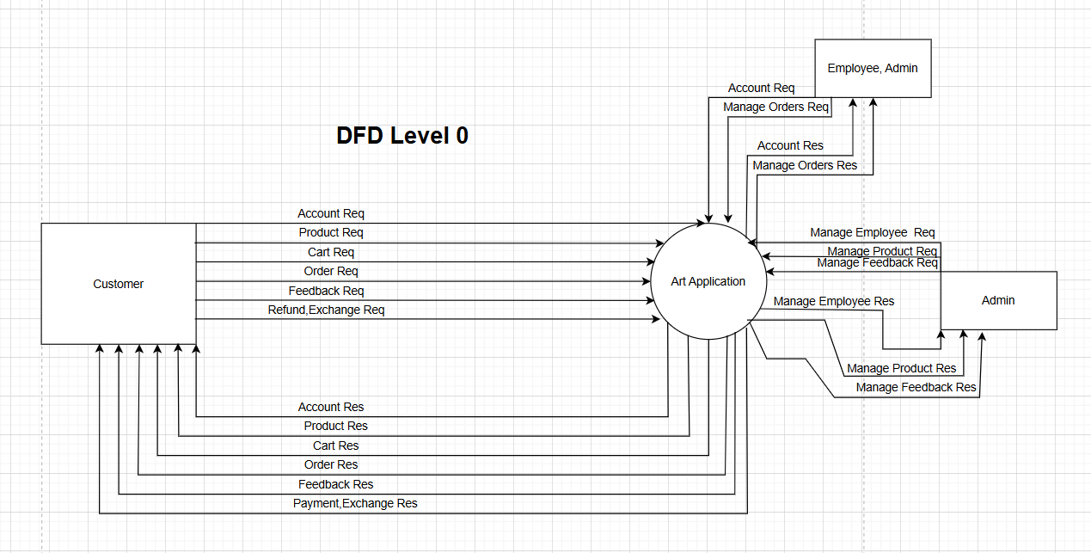

### **LEVEL 1**

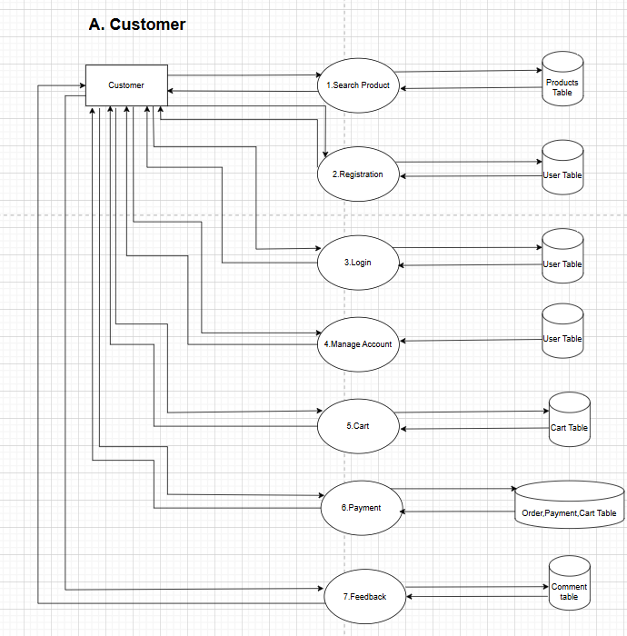

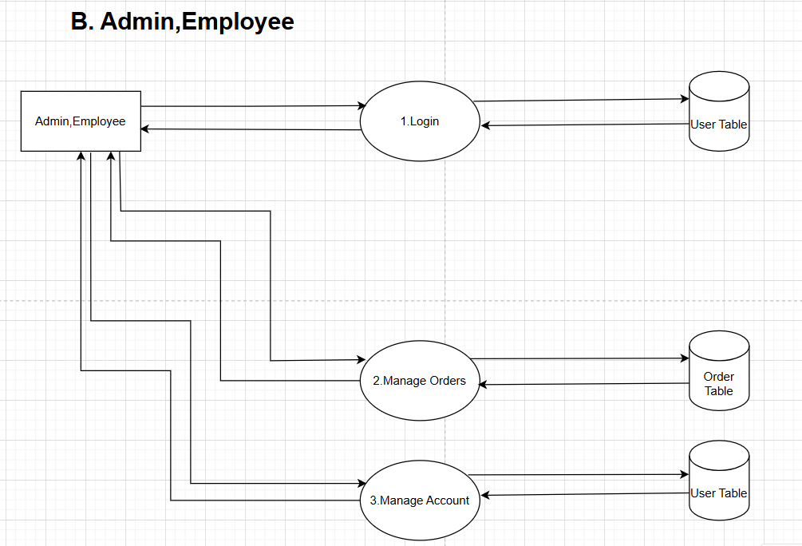

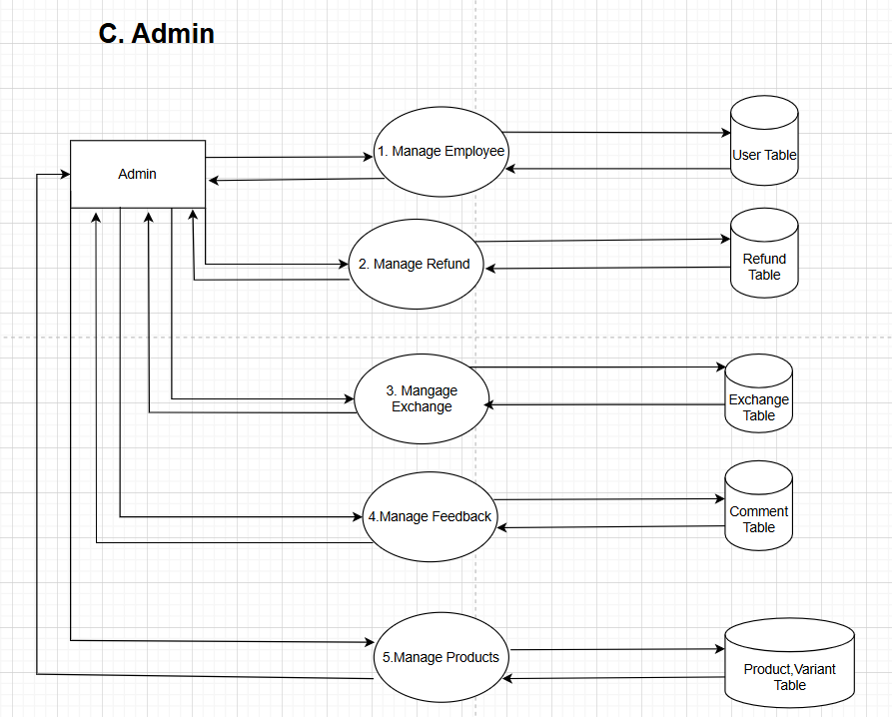

### **LEVEL 2**

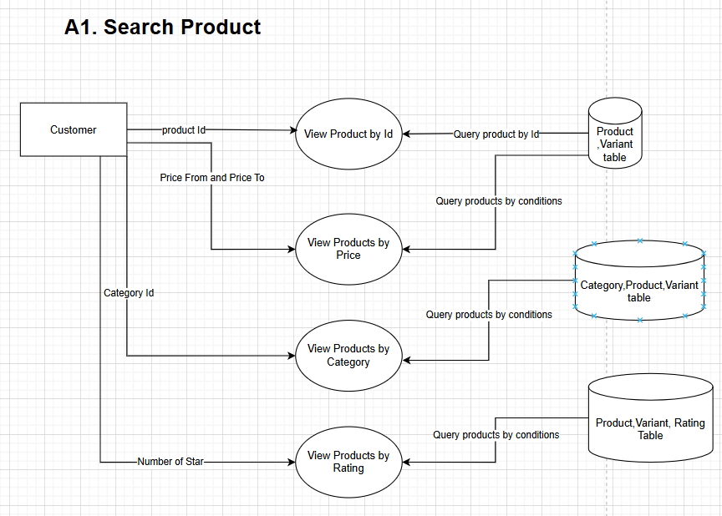

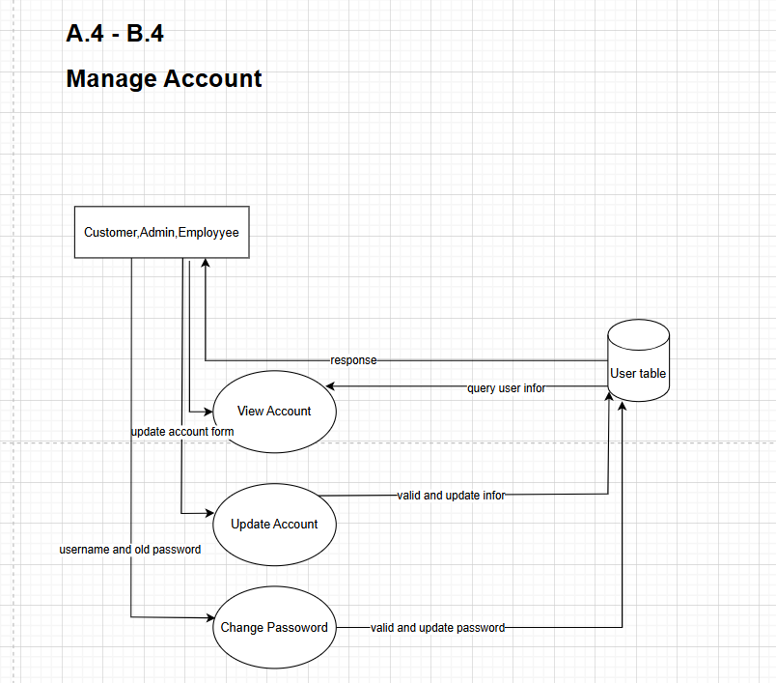

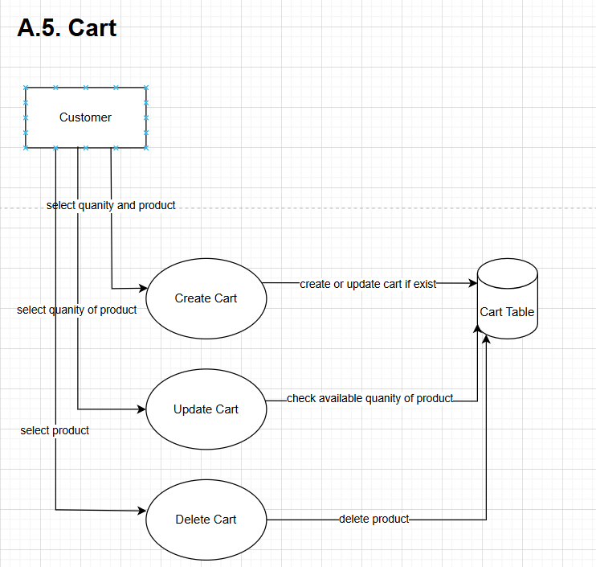

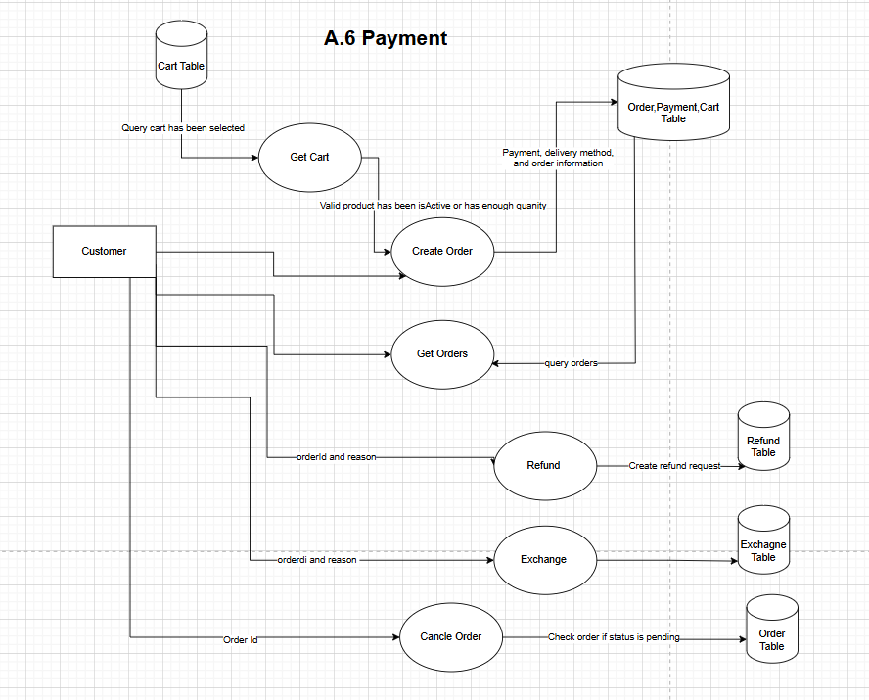

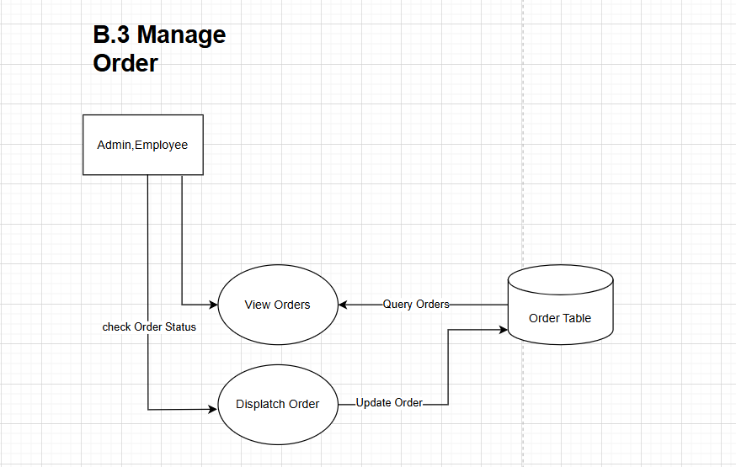

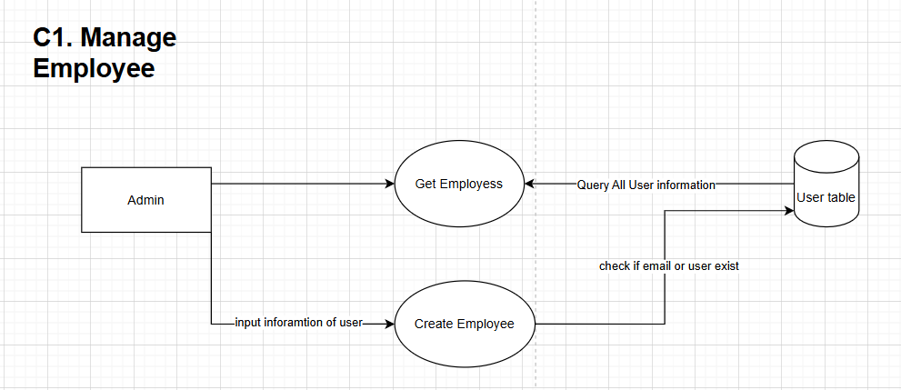

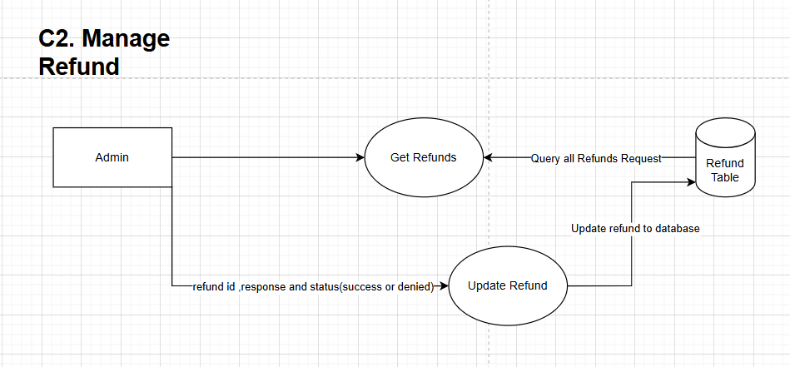

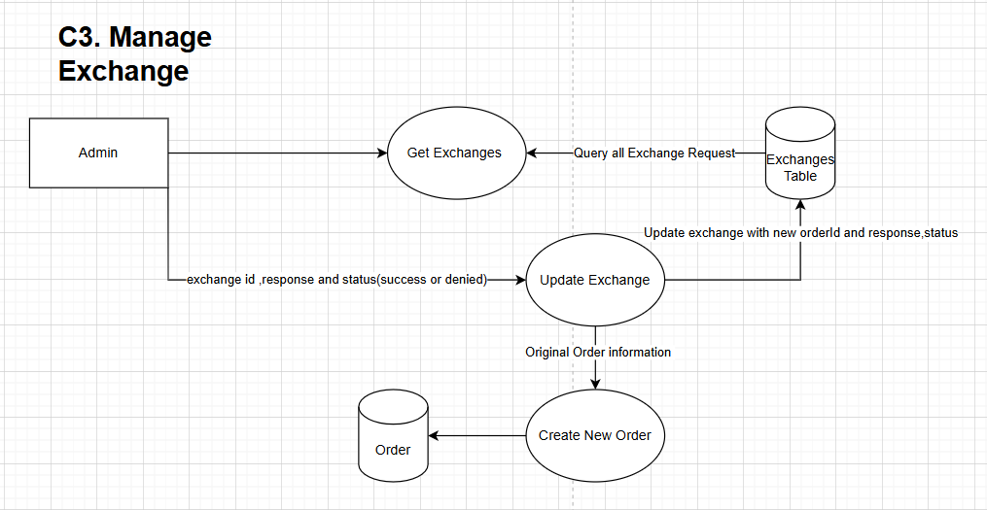

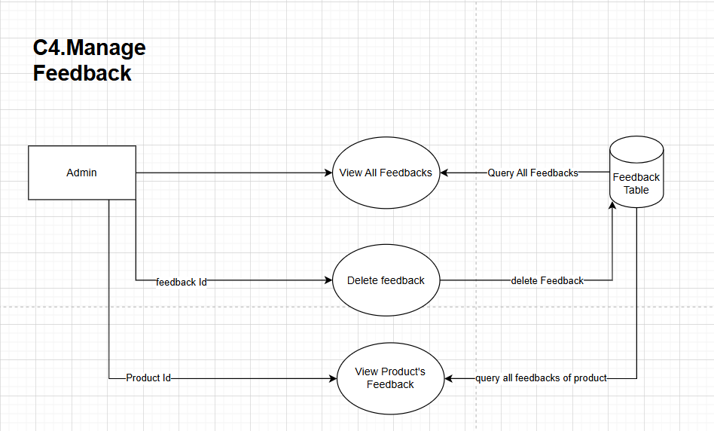

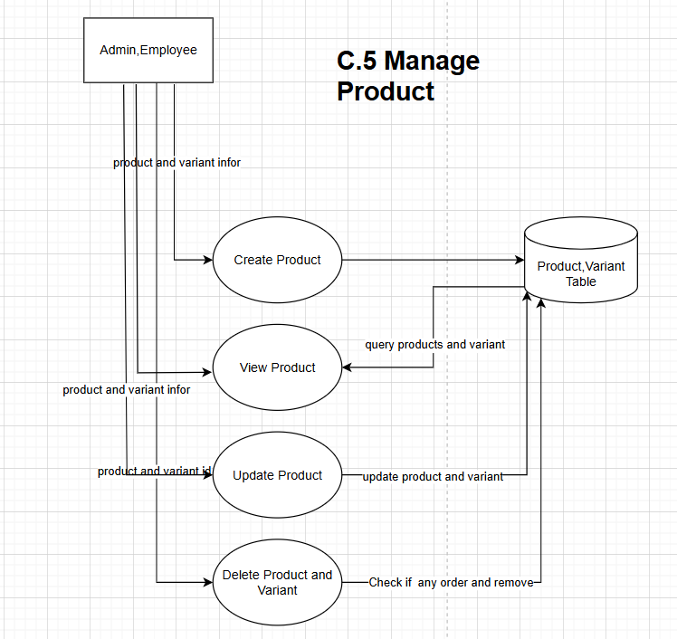

## **GUI STANDARDS DOCUMENT**

|  |  |
| --- | --- |
| **Logo** | **Header** |
| **Navigation menu** | |
| **Main content** | |
| **Footer** | |

**Frontend Web**

|  |  |
| --- | --- |
| **Logo** | **Header** |
| **Main navigation menu** | **Content** |

**Admin page**

## **TASKSHEET REVIEW 2**

|  |  |  |  |  |  |  |  |
| --- | --- | --- | --- | --- | --- | --- | --- |
| **Project: Liquor Stores** | | **Project Name** | **Activity Plan Prepared By** | **Date of Preparation of Activity Plan:** | | | |
| **Sr./ No.** | **Task** | **Actual Start Date** | **Actual Days** | **Team member name** | **Status** |
| **1** | **Usecase** | **Online Shopping**  **Cart** | Tân | 24/06/2024 | 1 | Giữ | Completed |
| **2** | **E-R Diagram** | 24/06/2024 | 1 | Tân, Giữ | Completed |
| **3** | **Database** | 24/06/2024 | 1 | Nhân, Tân, Giữ, Mai | Completed |
| **4** | **Algorithms** | 24/06/2024 | 1 | Giữ | Completed |
| **5** | **Gui standards document** | 24/06/2024 | 1 | Giữ | Completed |
| **6** | **DFD** | 24/06/2024 | 1 | Nhân | Completed |
| **7** | **Task Sheet** | 24/06/2024 | 1 | Giữ | Completed |
| Date: 24 June 2024 | | | | | | | |
| **Signature of Instructor:**  **MR.DINH HOAI VU** | | | | **Signature of Team Leader:**  **MR. NGO DINH TAN** | | | |

# **C. REVIEW 3**

## **UI Design**

### **Home page**

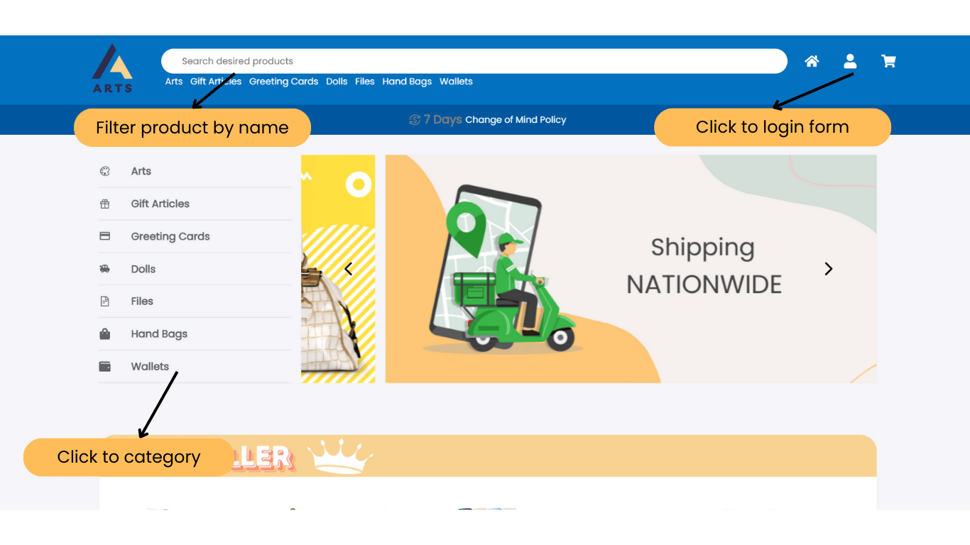

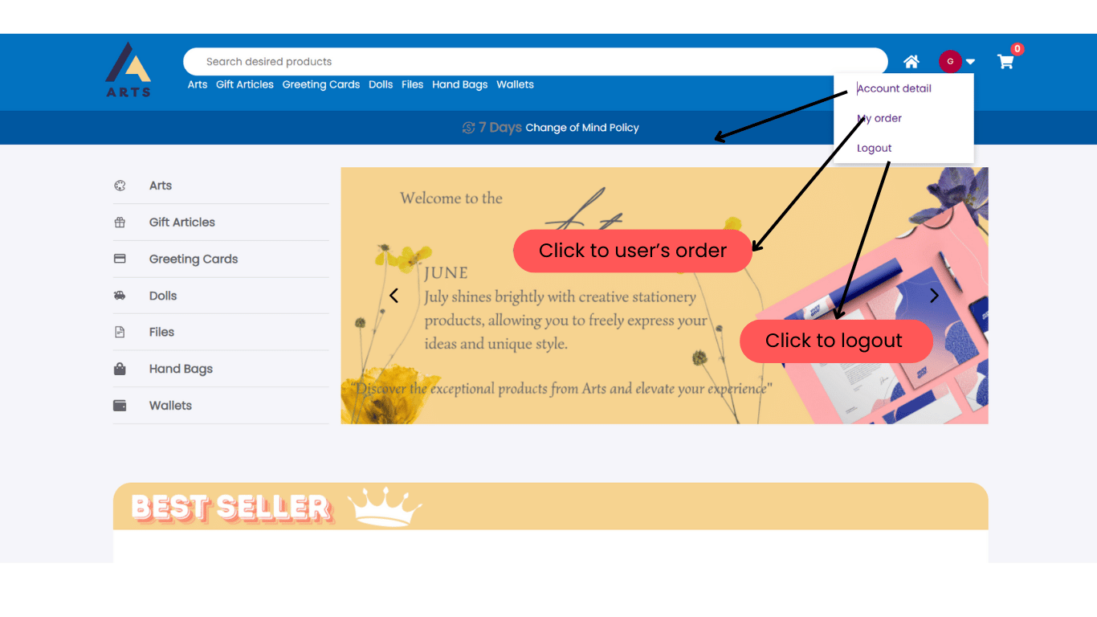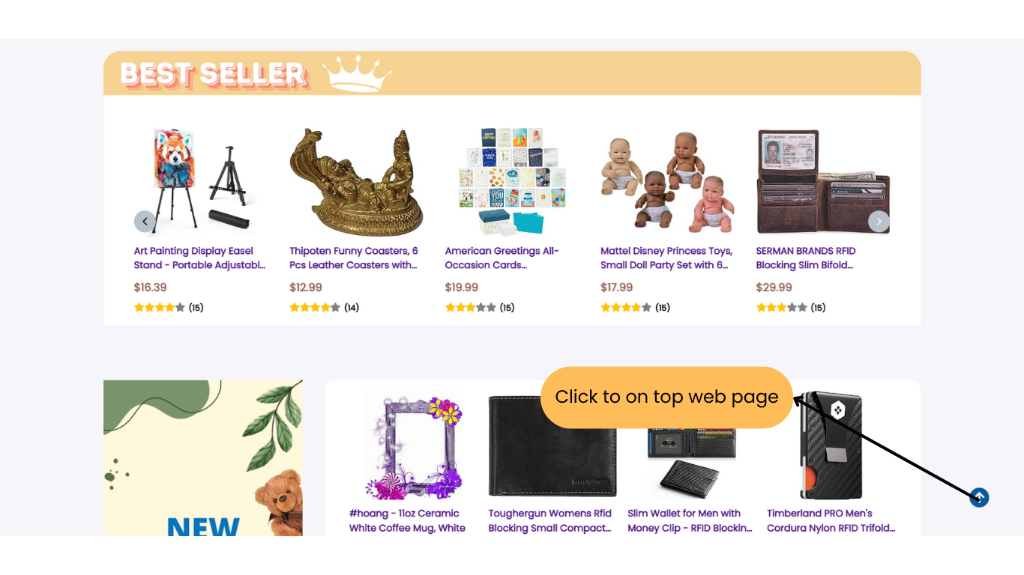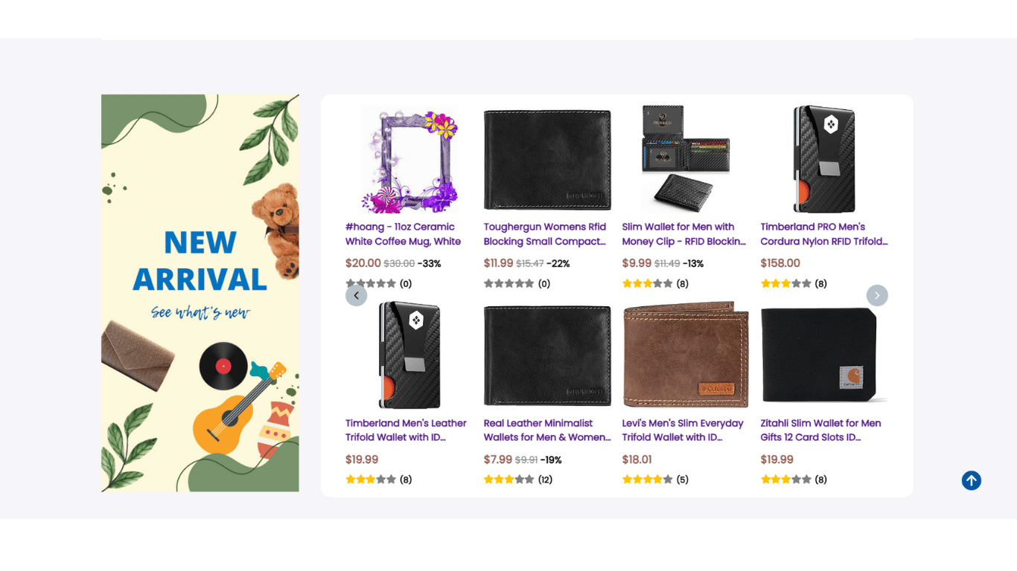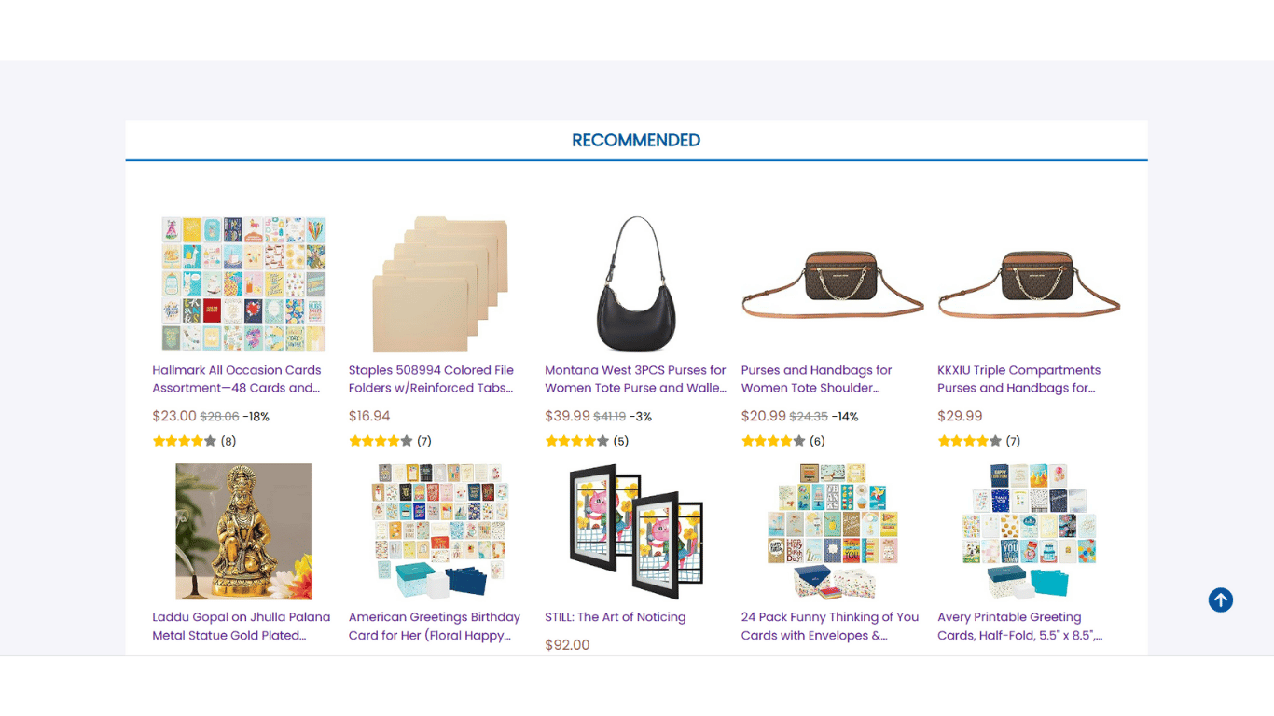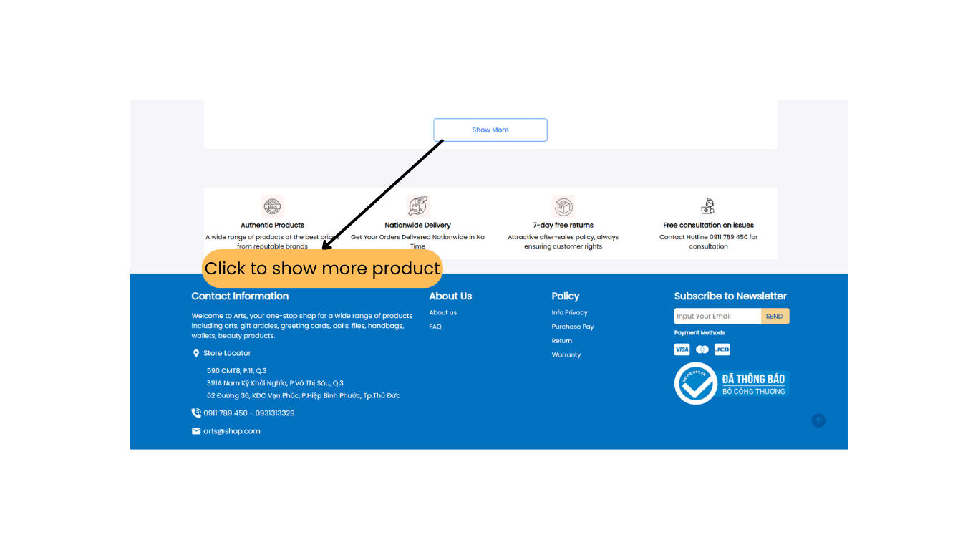

### **Product detail**

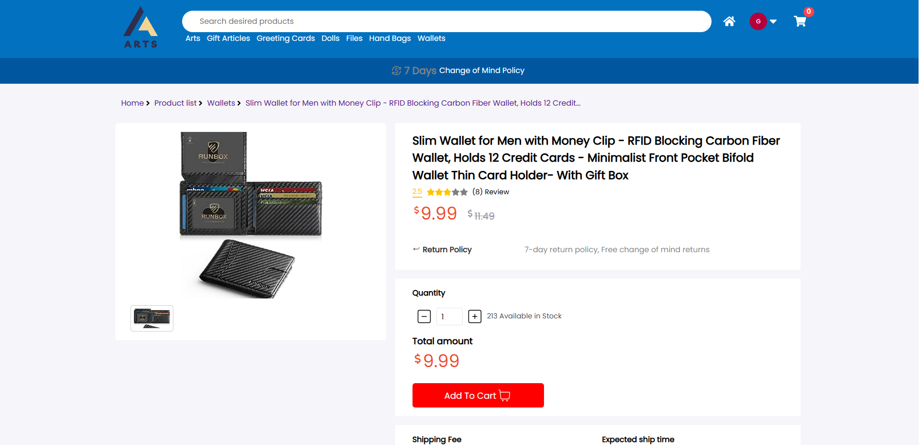

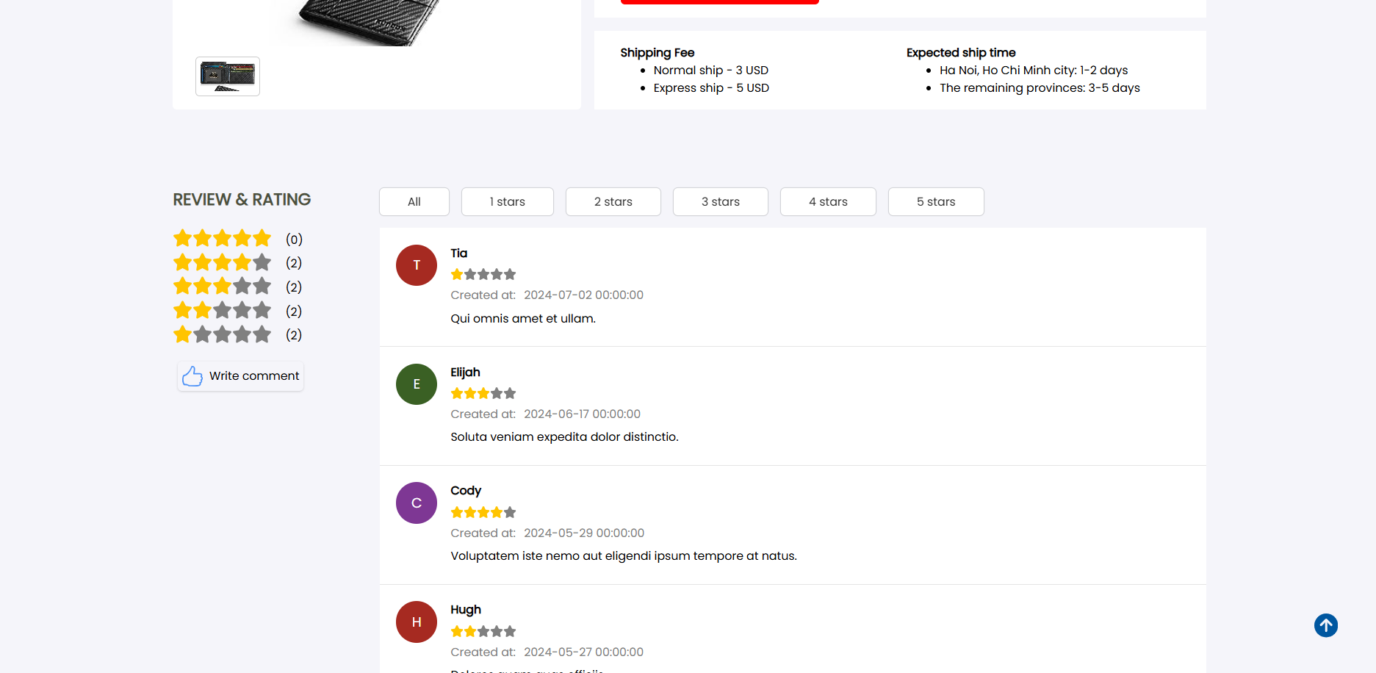

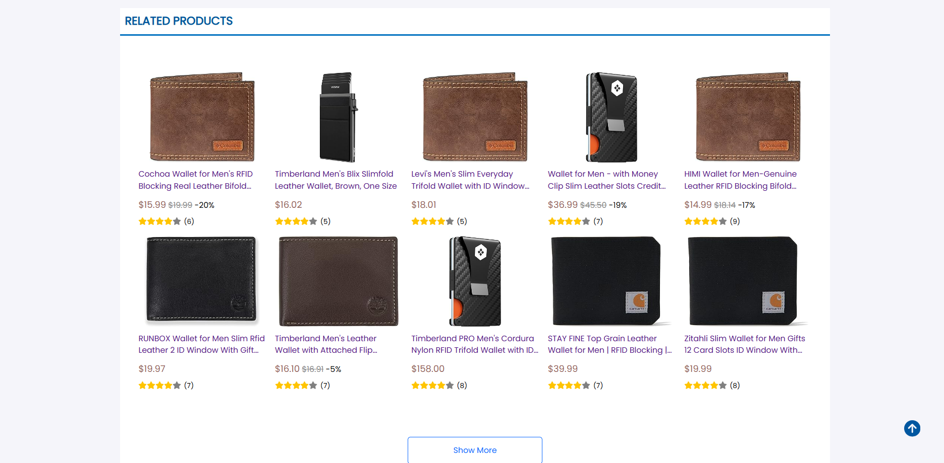

### **Rating and comment**

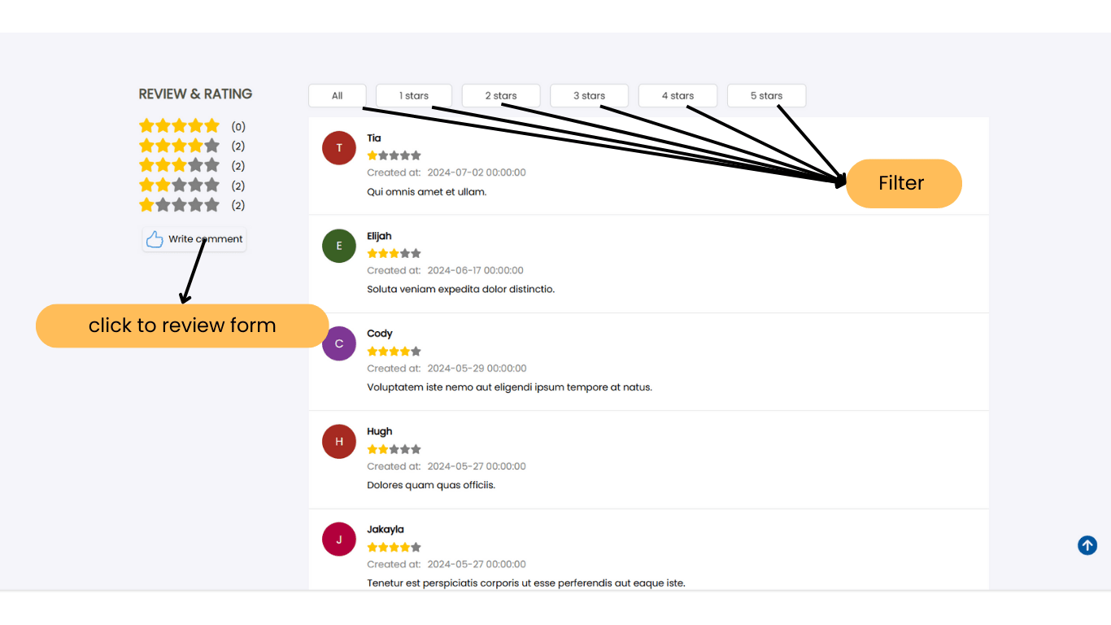

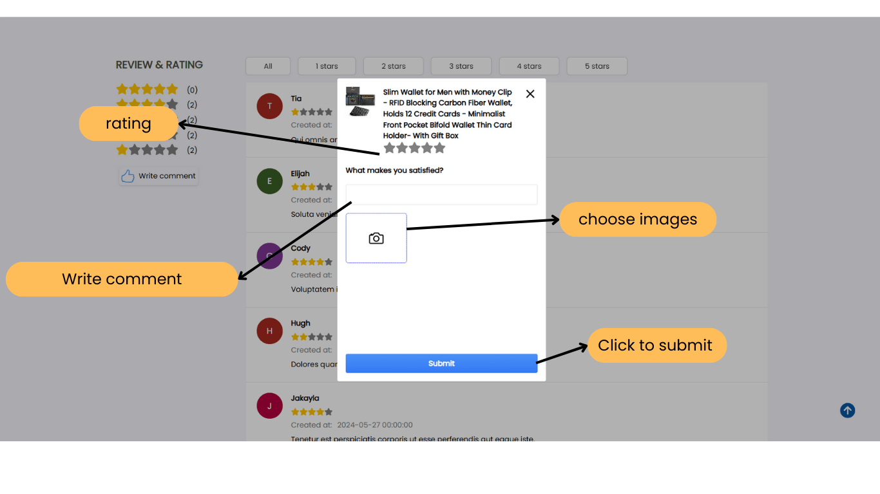

### **Account information**

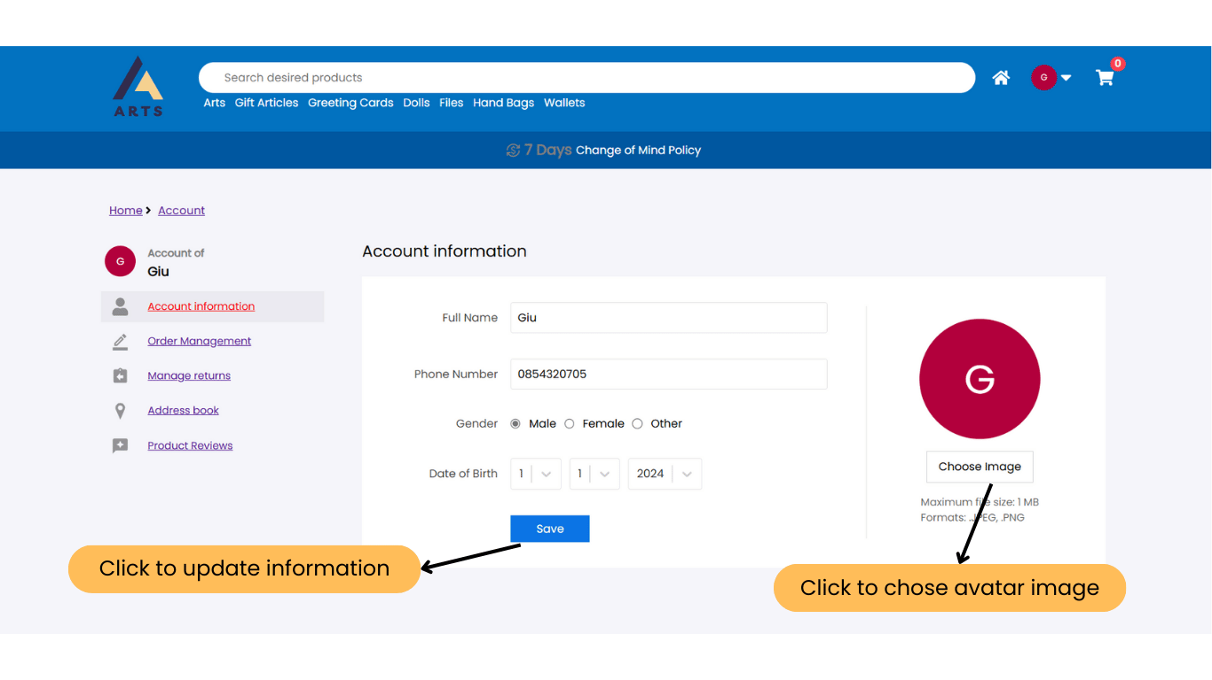

### **Address book page**

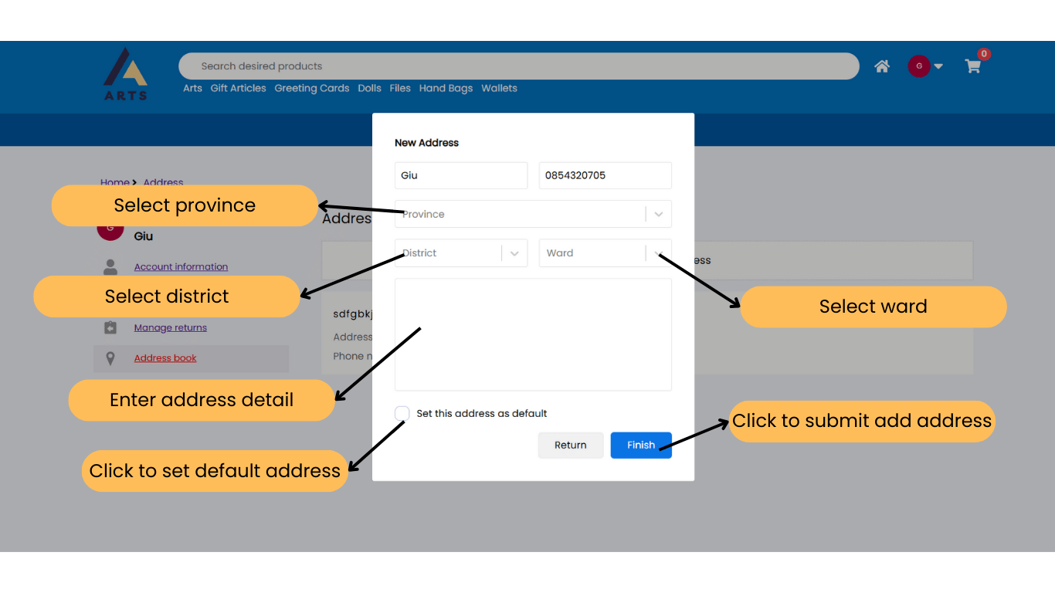

### **Register page**

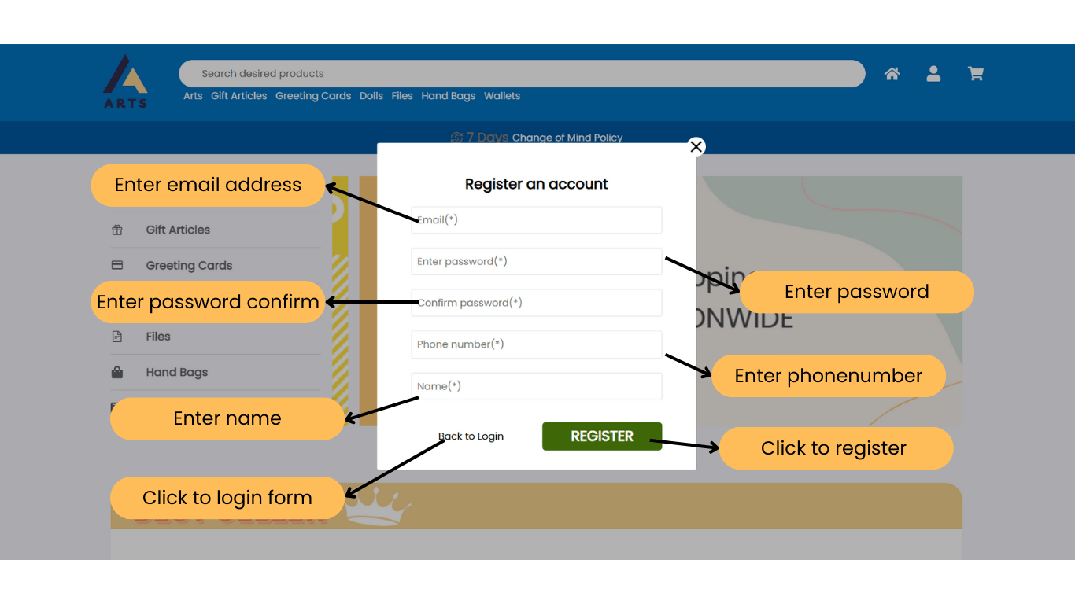

### **Login page**

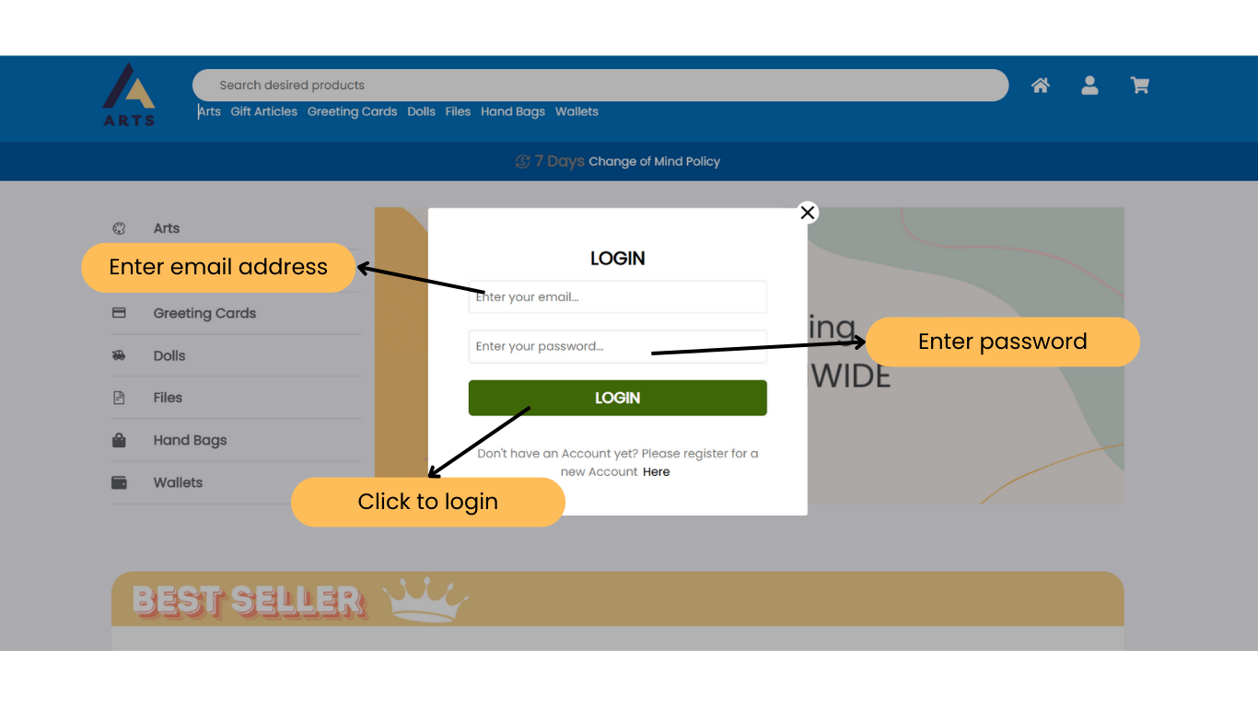

### **Manage products page**

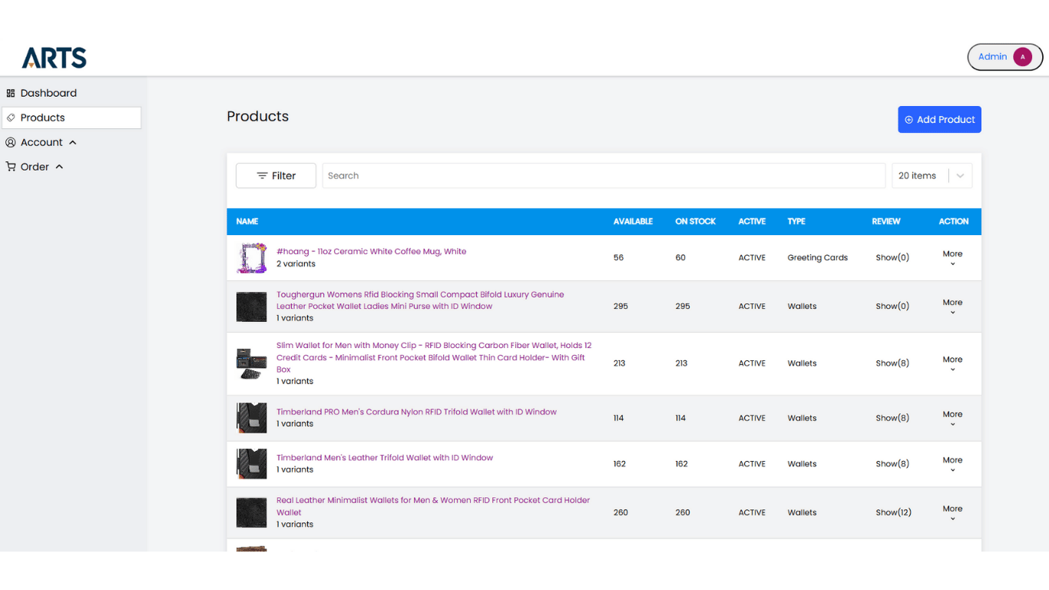

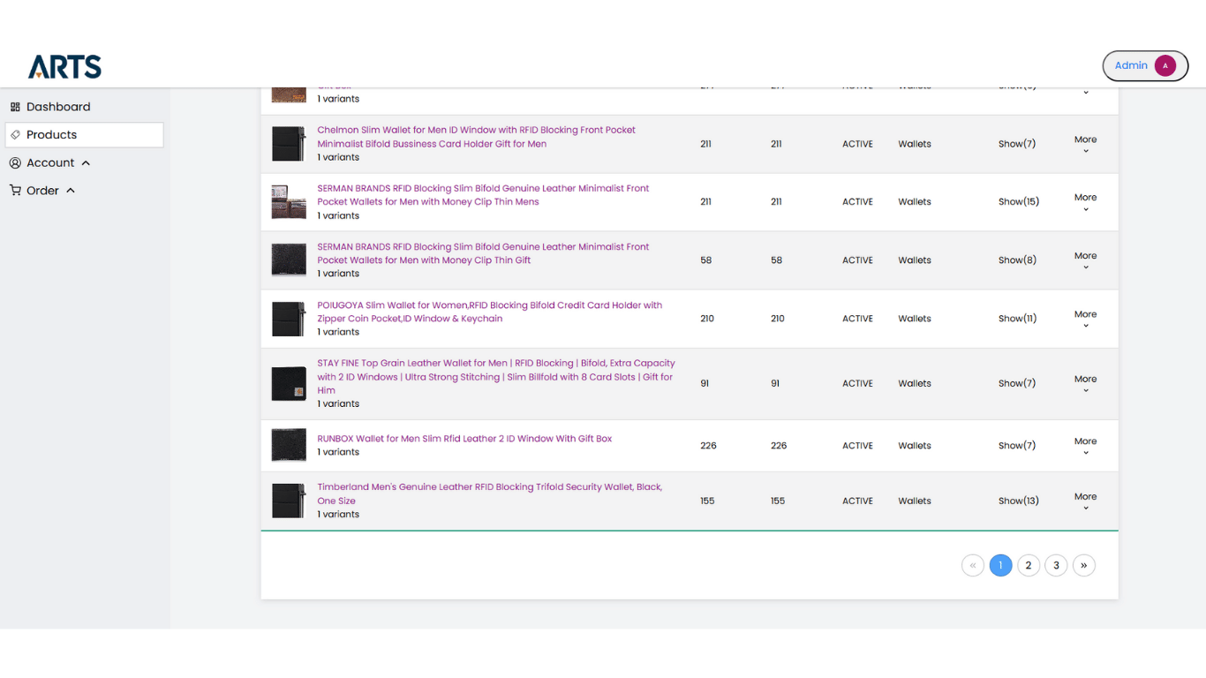

### **Create Product**

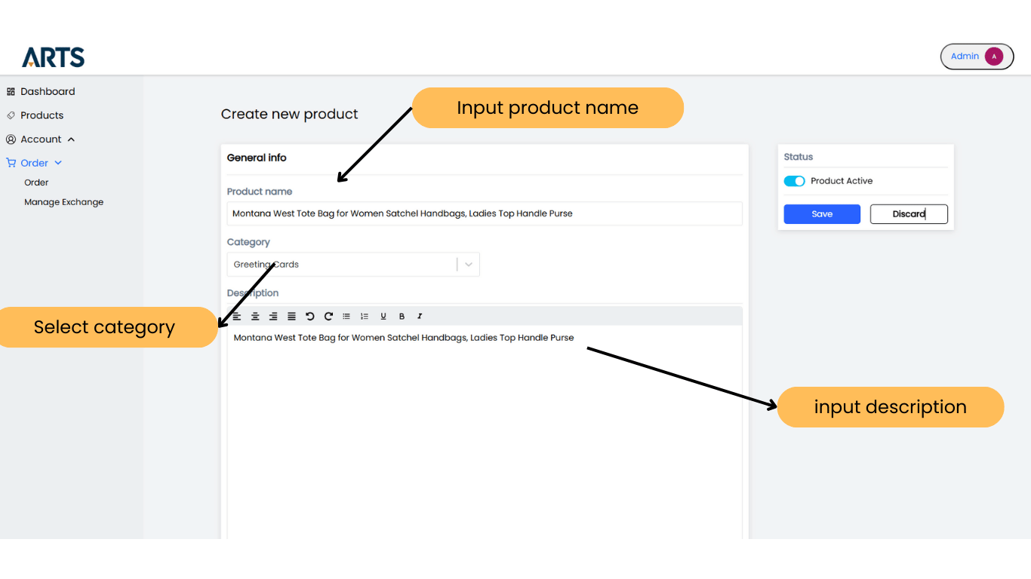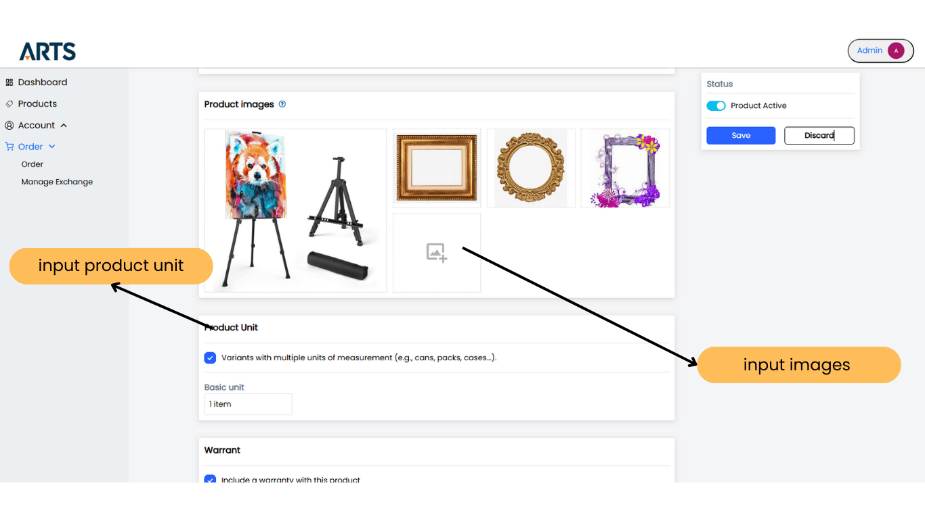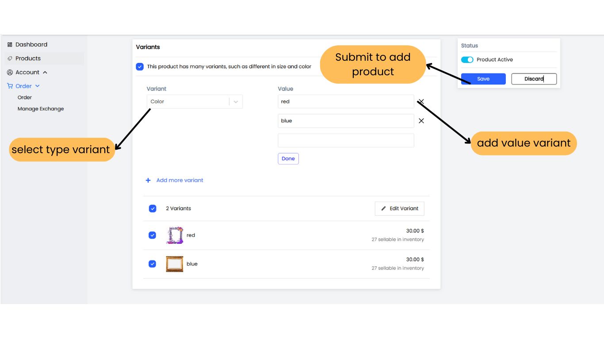

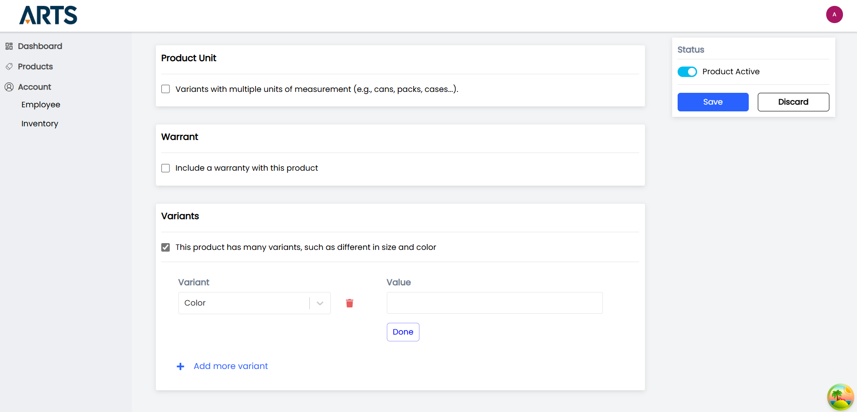

### **Manage employee page**

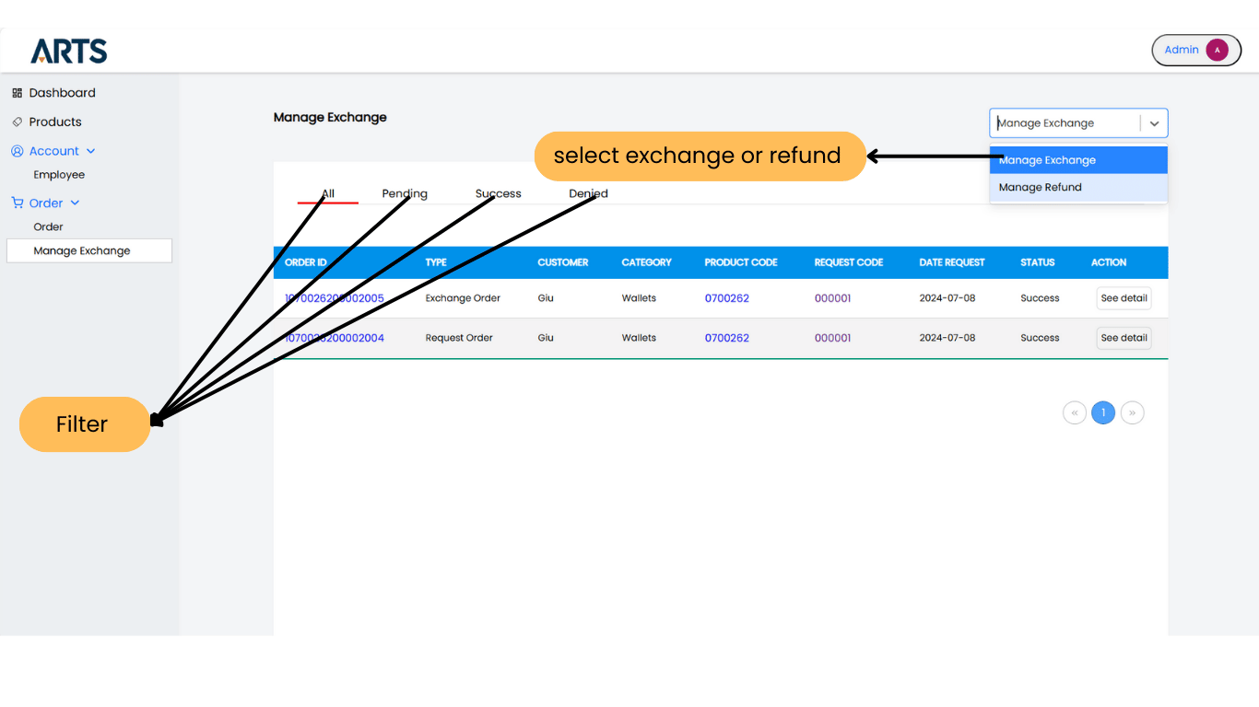

### **Create employee page**



### **Dashboard page**

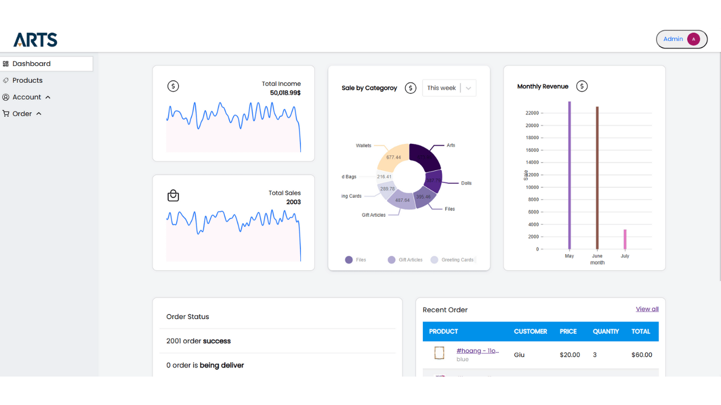

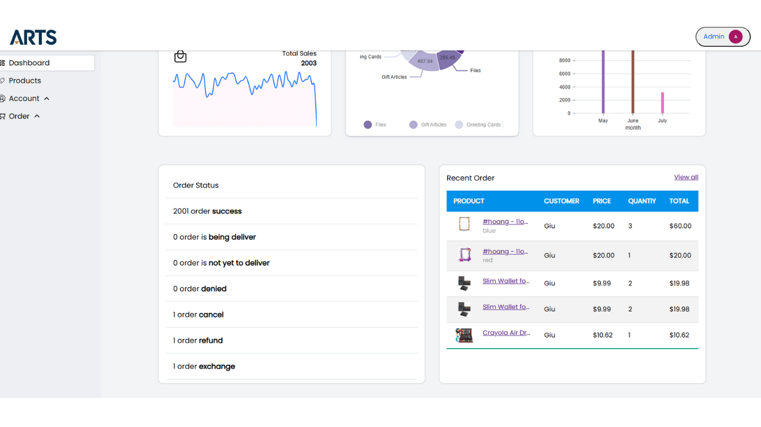

### **13. Order and payment page**

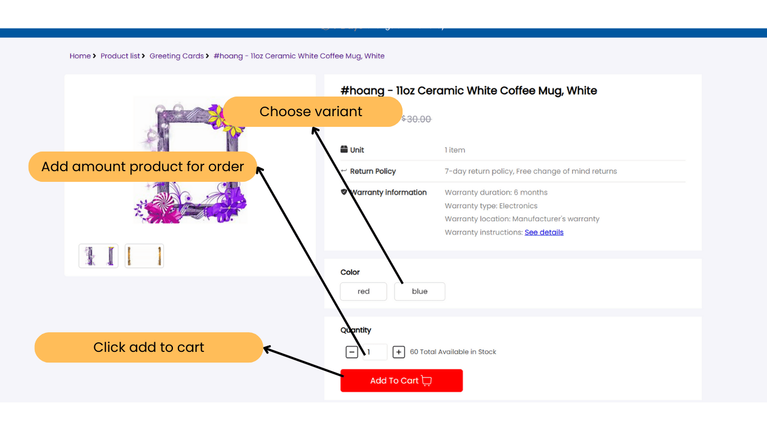

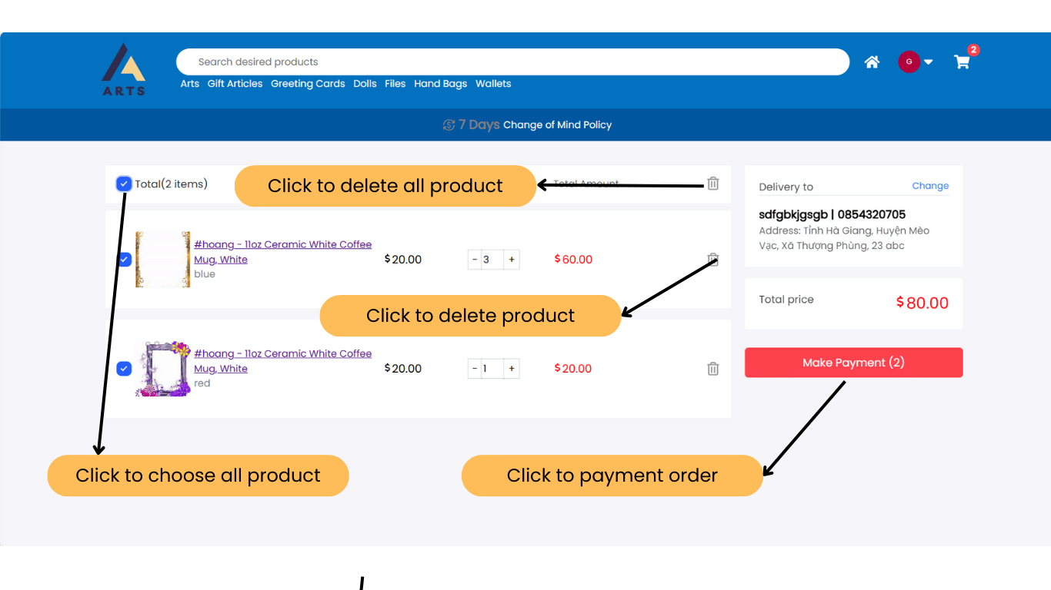

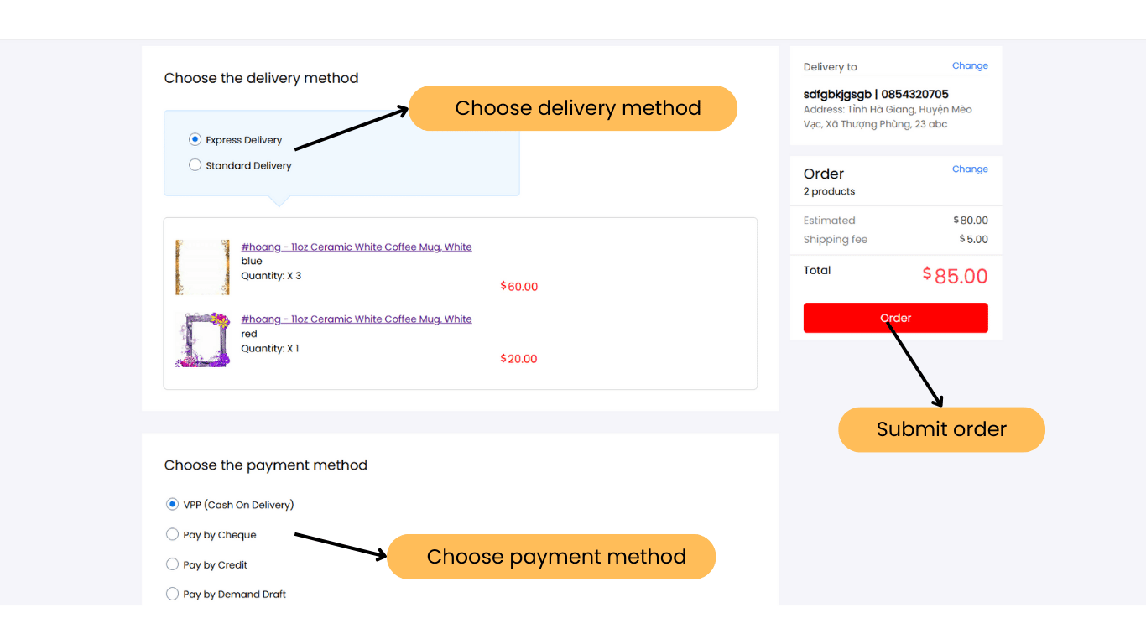

### **14. Login form admin**

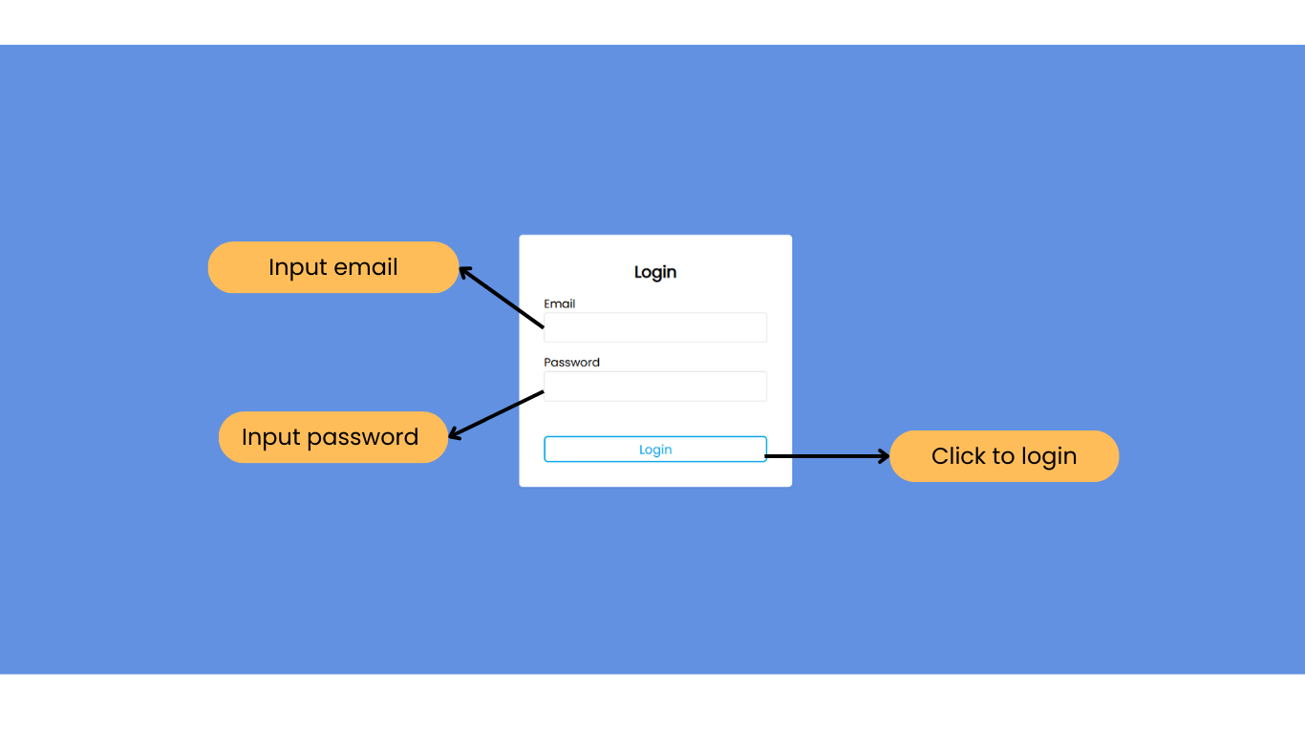

**15. Manage Exchange** 

### **16. Create employee**

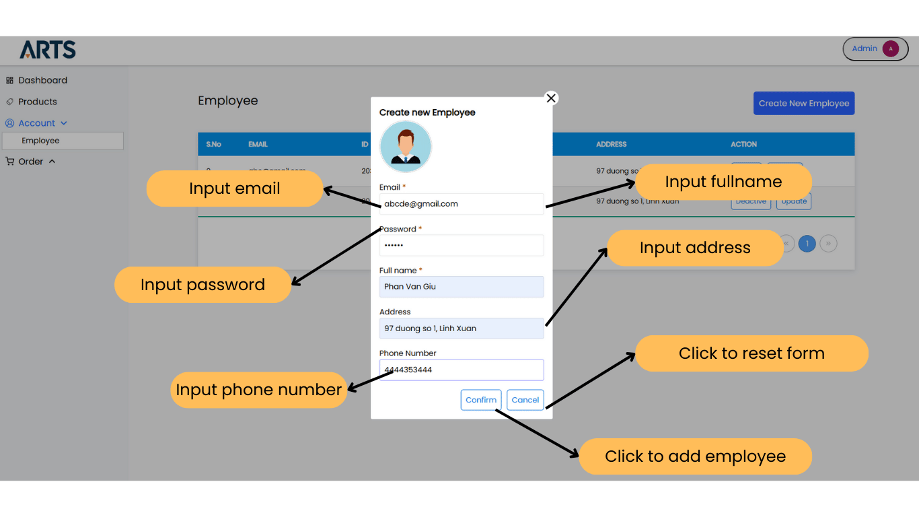

## **SITE MAP**

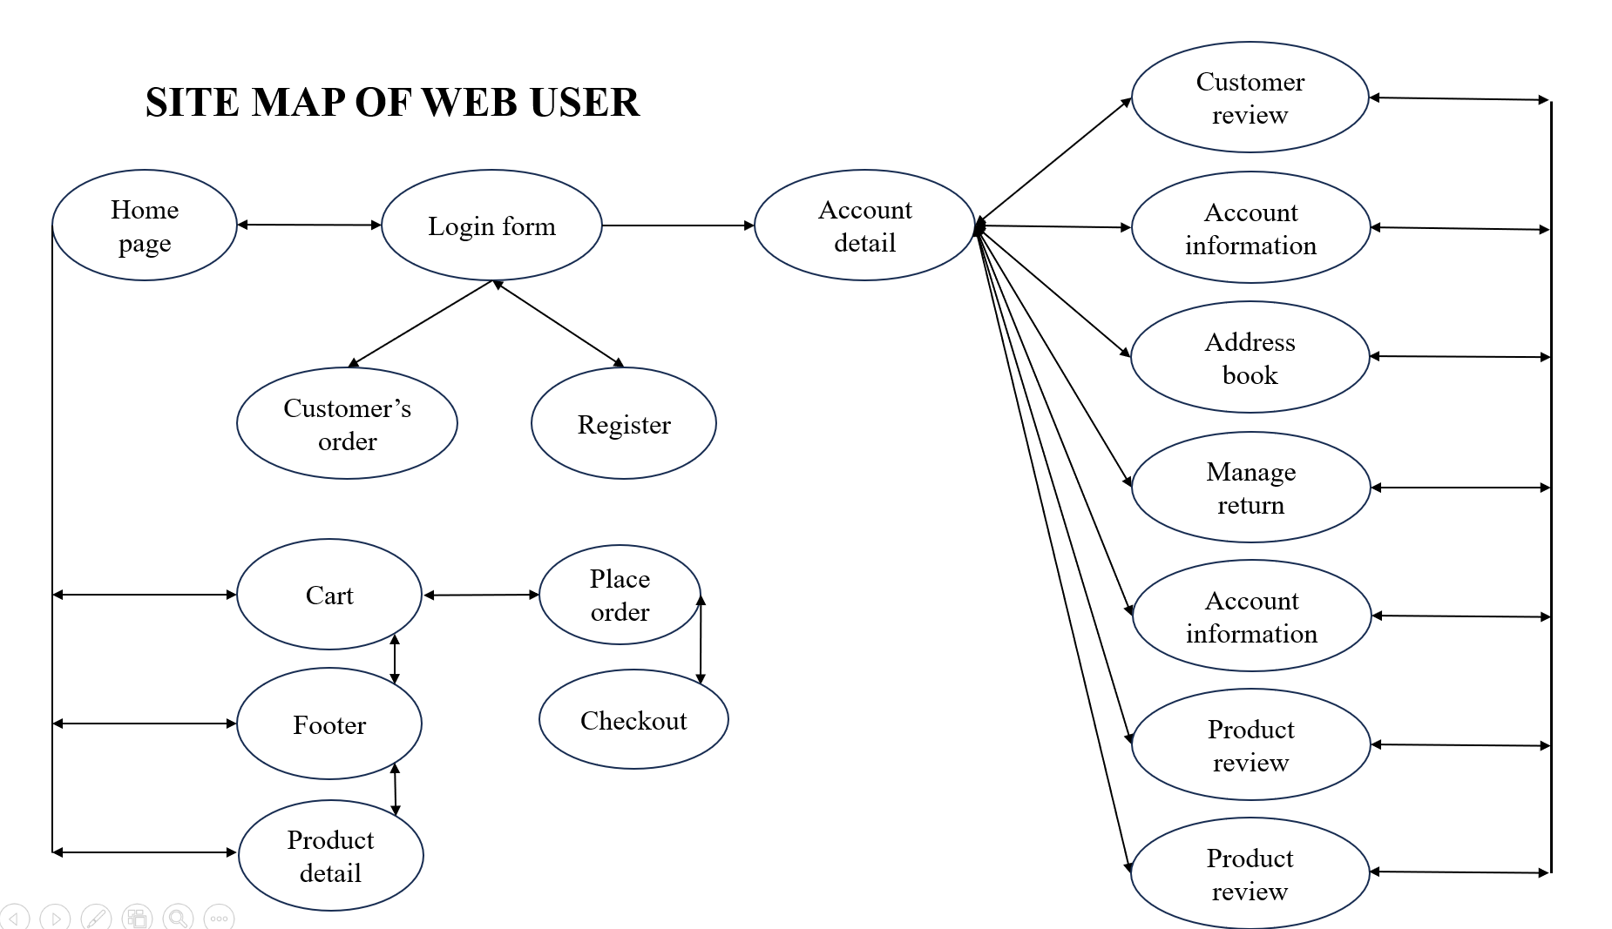

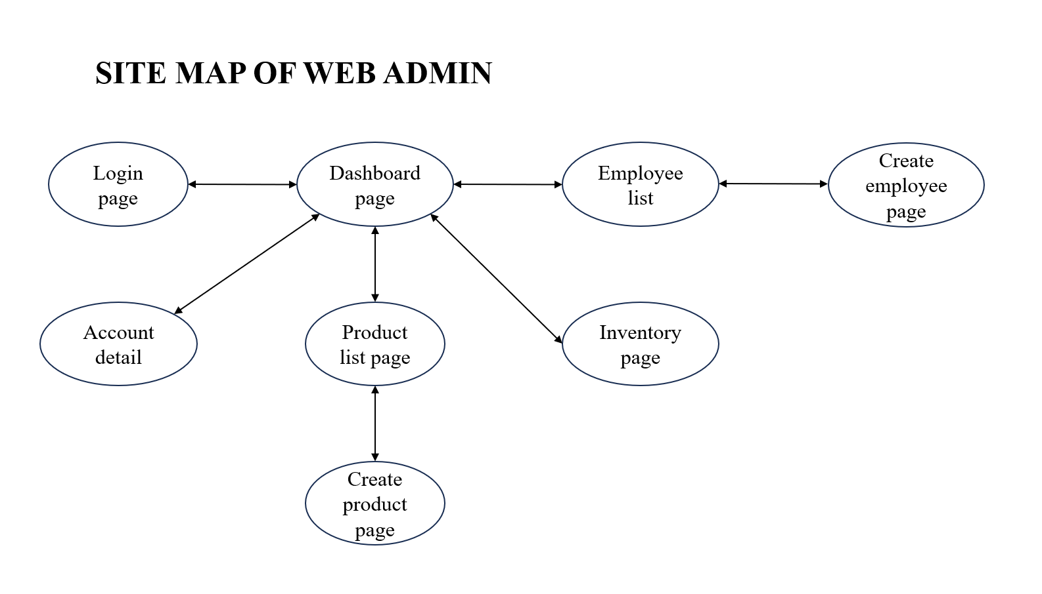

## **UNIT TESTING CHECK LIST**

|  |  |  |  |
| --- | --- | --- | --- |
| No | Filed | Validation | Show error |
| **1** | Email | Duplicate data | Email already exists |
| Require | Email must not leave blank. |
| **2** | Password | /^[A-Za-z0-9]{6,}$/; | Lowercase and uppercase. I need at least 6 characters. |
| Require | Password must not leave blank. |
| <= 100 characters | Less than 100 characters |
| **3** | Password confirm | Require | Password confirm not null |
| Password confirm match password | Password confirm not match the password |
| **4** | Fullname | Require | Fullname must not leave blank. |
| **5** | Address | <= 200 characters | Less than 200 characters |
| **6** | NameType | <= 20 characters | Less than 20 characters |
| Require | NameType not null |
| **7** | ProductName | Require | ProductName not null |
| <= 100 characters | Less than 100 characters |
| **8** | AttributeValue | <= 50 characters | Less than 50 characters |
| **9** | CatgoryName | Require | CatgoryName not null |
| <= 100 characterss | Less than 100 characters |
| **10** | PhoneNumber | [0-9] | Pattern error |
| <= 200 characters | Less than 200 characters |
| **11** | Rating | Require | Rating before comment |

## **TASKSHEET REVIEW 3**

|  |  |  |  |  |  |  |  |
| --- | --- | --- | --- | --- | --- | --- | --- |
| **Project: Liquor Stores** | | **Project Name** | **Activity Plan Prepared By** | **Date of Preparation of Activity Plan:** | | | |
| **Sr./ No.** | **Task** | **Actual Start Date** | **Actual Days** | **Team member name** | **Status** |
| **1** | **UI design** | **Online Shopping**  **Cart** | Tân | 27/06/2024 | 10 | Giữ ,  Tân  Nhân,  Mai | Completed |
| **2** | **Site map** | 27/06/2024 | 10 | Giữ | Completed |
| **3** | **Unit testing check list** | 27/06/2024 | 10 | Giữ | Completed |
| **4** | **Login/register (admin,customer**  **,employee)** | 27/06/2024 | 10 | Tân | Completed |
| **6** | **Customer Information** | 27/06/2024 | 10 | Tân |  |
| **7** | **Homepage/ product page** | 27/06/2024 | 10 | Tân | Completed |
| **8** | **Manage product** | 27/06/2024 | 10 | Tân | Completed |
| **9** | **Manage order** | 27/06/2024 | 10 | Tân | Completed |
| **10** | **Manage employee** | 27/06/2024 | 10 | Tân | Completed |
|  | **Address Book** | 27/06/2024 | 10 | Tân | Completed |
| **11** | **Manage Cart** | 27/06/2024 | 10 | Nhân | Completed |
| **12** | **Export revenue** | 27/06/2024 | 10 | Nhân | Completed |
| **13** | **Manage Exchange/ refund** | 27/06/2024 |  | Nhân | Completed |
| **14** | **Product listing** | 27/06/2024 | 10 | Mai | Completed |
| **15** | **Payment** | 27/06/2024 | 10 | Mai | Completed |
| **16** | **About us,**  **FAQ, Info Privacy,**  **Purchase Page,**  **Return,**  **Warranty(static information page)** | 27/06/2024 | 10 | Mai |  |
| **17** | **Manage review** | 27/06/2024 | 10 | Giữ |  |
| **18** | **Video guide** | 05/07/2024 | 1 | Giữ | Completed |
| **19** | **Installation guide** | 10/07/2024 | 1 | Nhân | Completed |
| **20** | **Task Sheet** | 27/06/2024 | 10 | Giữ | Completed |
| Date: 27 June 2024 | | | | | | | |
| **Signature of Instructor:**  **MR.DINH HOAI VU** | | | | **Signature of Team Leader:**  **MR. NGO DINH TAN** | | | |